I. OVERVIEW

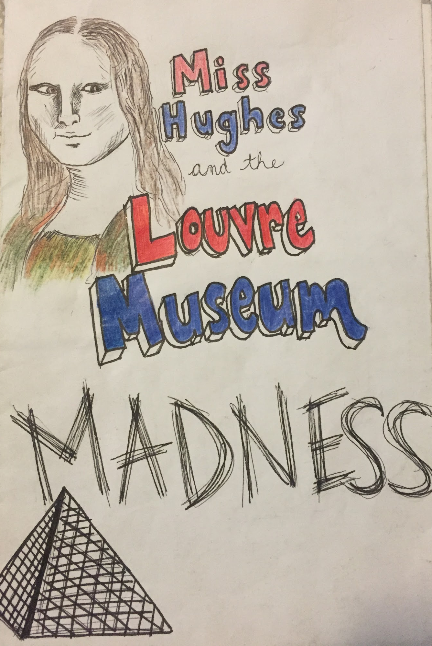

LESSON TITLE: The Art of the Comic Book: An Exploration in Narrative Artwork
LESSON SUMMARY: In this lesson, students will explore the technique of drawing the human form, and use their newfound knowledge to create a comic book.

TEACHER(S) NAME: Taylor Hughes
GRADE LEVEL: 6th-8th Grade
CLASS NAME: 6th Grade Art, LD 8th Grade CLASS SIZE: 15-27 Students
CLASS TIME/DATE: 88 Minutes 2-3 Days/week 17 Total Session(s)/Days

A. BIG IDEA:
Narrative

B. ENDURING UNDERSTANDINGS:
Being able to tell a story is a fundamental life skill. We are constantly faced with the challenge of how to interpret and describe events to others, and ultimately the world, around us. Being able to tell a story allows for the opportunity to record important life events, history, and the world. In art, a narrative is a powerful creation. Being able to create a narrative work of art allows for an artist to use his or her own artistic voice to record an event, including a crucial viewpoint in the process.

C. ESSENTIAL QUESTIONS:
- What is narrative?
- What is narrative in artwork?
- Why is it important to be able to tell stories?
- Why is it important to create narrative works of art?

D. BACKGROUND INFORMATION
- The 6th grade students are expected to have fundamental knowledge on basic drawing and art skills - mostly related to the elements of art. Students should be able to discuss how to use line, shape, light, etc. in their artwork to the best of their ability.

E. MATERIALS/EQUIPMENT, ROOM ARRANGEMENT
1. MATERIALS/EQUIPMENT:
  - Drawing pencils
  - Marshmallows (mini and jumbo)
  - Toothpicks
  - Paper towels
  - Erasers
  - Newsprint paper - 8 ½” x 11”
  - Drawing paper - 18”x24”
  - Markers
  - Colored Pencils
  - Rulers
  - Various handouts (see Section V)
  - Chalkboard/chalk
2. ROOM ARRANGEMENT:
  - Students will be arranged in tables, all having a clear view of the chalkboard and easy walking access to various materials in the back of the room. There will be no more than 5 students at a table.

F. VOCABULARY and REFERENCES/SOURCES
- VOCABULARY:
  - Narrative
  - Proportion
  - Figure Drawing
  - Gesture
  - Interaction of Text and Image
  - Comic book
- REFERENCES/SOURCES:
  - http://www.biography.com/people/bill-watterson-9525322

II. OBJECTIVES and STANDARDS

A. OBJECTIVES:
- The students will be able to demonstrate an understanding of figure drawing through preliminary sketch work and in the creation of a final work of narrative art.
- The students will be able to create a narrative work of art with the creation of a comic book.
- The students will be able to demonstrate an understanding of how to interact text with image through the creation of a comic book.
- The students will be able to observe the comics of Bill Watterson and identify the most successful elements of his work to include in their own.

B. STANDARDS
- NJCCC Art:
  - 1.2.8.A.3: Analyze the social, historical, and political impact of artists on culture and the impact of culture on the arts.
    - Students will be examining a famous comic strip, Calvin and Hobbes, acknowledging cultural references and how the artist may have been reflecting to events going on at the time.
  - 1.3.8.D.1: Incorporate various art elements and the principles of balance, harmony, unity, emphasis, proportion, and rhythm/movement in the creation of two- and three dimensional artworks, using a broad array of art media and art mediums to enhance the expression of creative ideas (e.g. perspective, implied space, illusionary depth, value, and pattern).
    - The students will be creating a comic book that examines proportion and emphasis throughout, using various art media (colored pencil, marker, etc.) to express a creative idea in the form of a short story.
  - 1.3.8.D.5: Examine the characteristics, thematic content, and symbolism found in works of art from diverse cultural and historical eras, and use these visual statements as inspiration for original artworks.
    - Students will be examining the symbolism and strategies used in Calvin and Hobbes and use these visual statements as inspiration for their own comic book.
- NJCCC Non-art Subject:
  - CCSS.MATH.CONTENT.7.RP.A.2: Recognize and represent proportional relationships between quantities.
    - In this lesson, students will be examining the proportions of the human figure.
- National Core Visual Arts Standards (NCCAS):
  - VA:Cr1.2.6: Formulate an artistic investigation of personally relevant content for creating art.
    - In this lesson, students will be investigating a story that is personally significant to themselves, and creating it in a comic book form.
IV. LESSON ANALYSIS

A. STUDENT ASSESSMENT

1. Pre-Assessment: Stick figure drawings during day 1

2. Formative Assessment: Sketches, figure drawing book, class discussion, daily progress

3. Summative Assessment: Rubric

Criteria/Objective | Exemplary (A) | Good (B) | Satisfactory (C) | Needs Improvement
The students will be able to demonstrate an understanding of figure drawing through preliminary sketch work and in the creation of a final work of narrative art. | The student exhibited a clear understanding of how to draw a proper human. The sketches during the modeling stages of the assignment are extremely accurate. | The student exhibited an understanding of how to draw a proper human. The sketches during the modeling stages of the assignment are accurate. | The student exhibited a partial understanding of how to draw a proper human. The sketches during the modeling stages of the assignment are somewhat accurate, but are either missing elements or are proportionally incorrect.. | The student was unable to exhibit any trace of an understanding of how to draw a proper human. The sketches during the modeling stages of the assignment are inaccurate.
 | In the final work of art, the student was able to include figures in an incredibly accurate way that exceeded expectations. | In the final work of art, the student was able to include figures in an accurate way that exceeded expectations. | In the final work of art, the student was able to include figures in a somewhat accurate way that met or slightly missed expectations. | In the final work of art, the student was unable to include figures in an accurate way and did not meet any expectations.
The students will be able to create a narrative work of art with the creation of a comic book.  The students will be able to demonstrate an understanding of how to interact text with image through the creation of a comic book. | The student’s comic book tells an extremely creative and thorough story. The characters are well-established, and the story is very clear and unique. | The student’s comic book tells a creative and thorough story. The characters are well-established, and the story is very clear. | The student’s comic book tells a thorough story. The characters are somewhat established, however are not always identified well. Overall the story is somewhat clear. | The comic book does not tell a cohesive story. The character are either unclear or not present throughout the entire story, and are poorly identified. The story is unclear.
 | The student used text in an extremely appropriate manner, and was able to use mostly pictures to tell their story. The illustrations are advanced and technically sound and help to tell a story. | The student used text in an appropriate manner, and was able to use mostly pictures to tell their story. The illustrations are technically sound and help to tell a story. | The student used text in somewhat of an appropriate manner, and was able to use pictures to tell their story. There may be too much text that may overpower the images. The illustrations are somewhat technically sound and sometimes help to tell a story. | The student did not use text in an appropriate manner, and was unable to use pictures to tell their story. There may be too much text that may overpower the images. The illustrations are poorly rendered and do not help to tell a story.
The students will be able to observe the comics of Bill Watterson and identify the most successful elements of his work to include in their own. | The student was able to clearly identify the most successful elements of Watterson’s work through class discussion. | The student was able to identify the most successful elements of Watterson’s work through class discussion. | The student was somewhat able to identify the most successful elements of Watterson’s work through class discussion. | The student was unable to clearly identify the most successful elements of Watterson’s work through class discussion.
 | The student frequently participated in class discussion about the artist’s work and contributed thought-provoking and advanced ideas. | The student participated in class discussion about the artist’s work and contributed thought-provoking ideas. | The student participated occasionally in class discussion about the artist’s work and contributed a few thought-provoking ideas. | The student rarely participated in class discussion about the artist’s work, if at all. The student rarely contributed any of his/her ideas.
The student was able to include all 10 requirements on the checklist into their final work of art. | The student include all 10 requirements from the checklist. | The student included 8-8.5 requirements from the checklist. | The student included 7-7.5 requirements from the checklist. | The student included fewer than 7 requirements from the checklist.
Craftsmanship | The final book is beautifully crafted - completely free of folds, bends, rips and tears, etc. The student clearly took extreme care in the creation and keeping of their book. | The final book is well crafted - almost completely free of folds, bends, rips and tears, etc. The student clearly took good care in the creation and keeping of their book. | The final book is well crafted - only has a few folds, bends, rips and tears, etc. The student attempted to take good care in the creation and keeping of their book. | The final book is poorly crafted - has many folds, bends, rips and tears, etc. The student failed to take good care in the creation and keeping of their book.
Participation | The student kept up with the progress of the comic book, and occasionally was ahead of the group. The student worked efficiently and appropriately. | The student kept up with the progress of the comic book.. The student worked efficiently and appropriately. | The student kept up with the progress of the comic book for the most part, although may have fallen behind for a day or two.. The student worked somewhat appropriately. | The student failed to keep up with the progress of the comic book. The comic book was turned in late, and the student worked did not work efficiently or appropriately.
Total Points or Grade:

Teacher Comments:

B. ASSESSING ARTWORK
EXEMPLARY WORK:
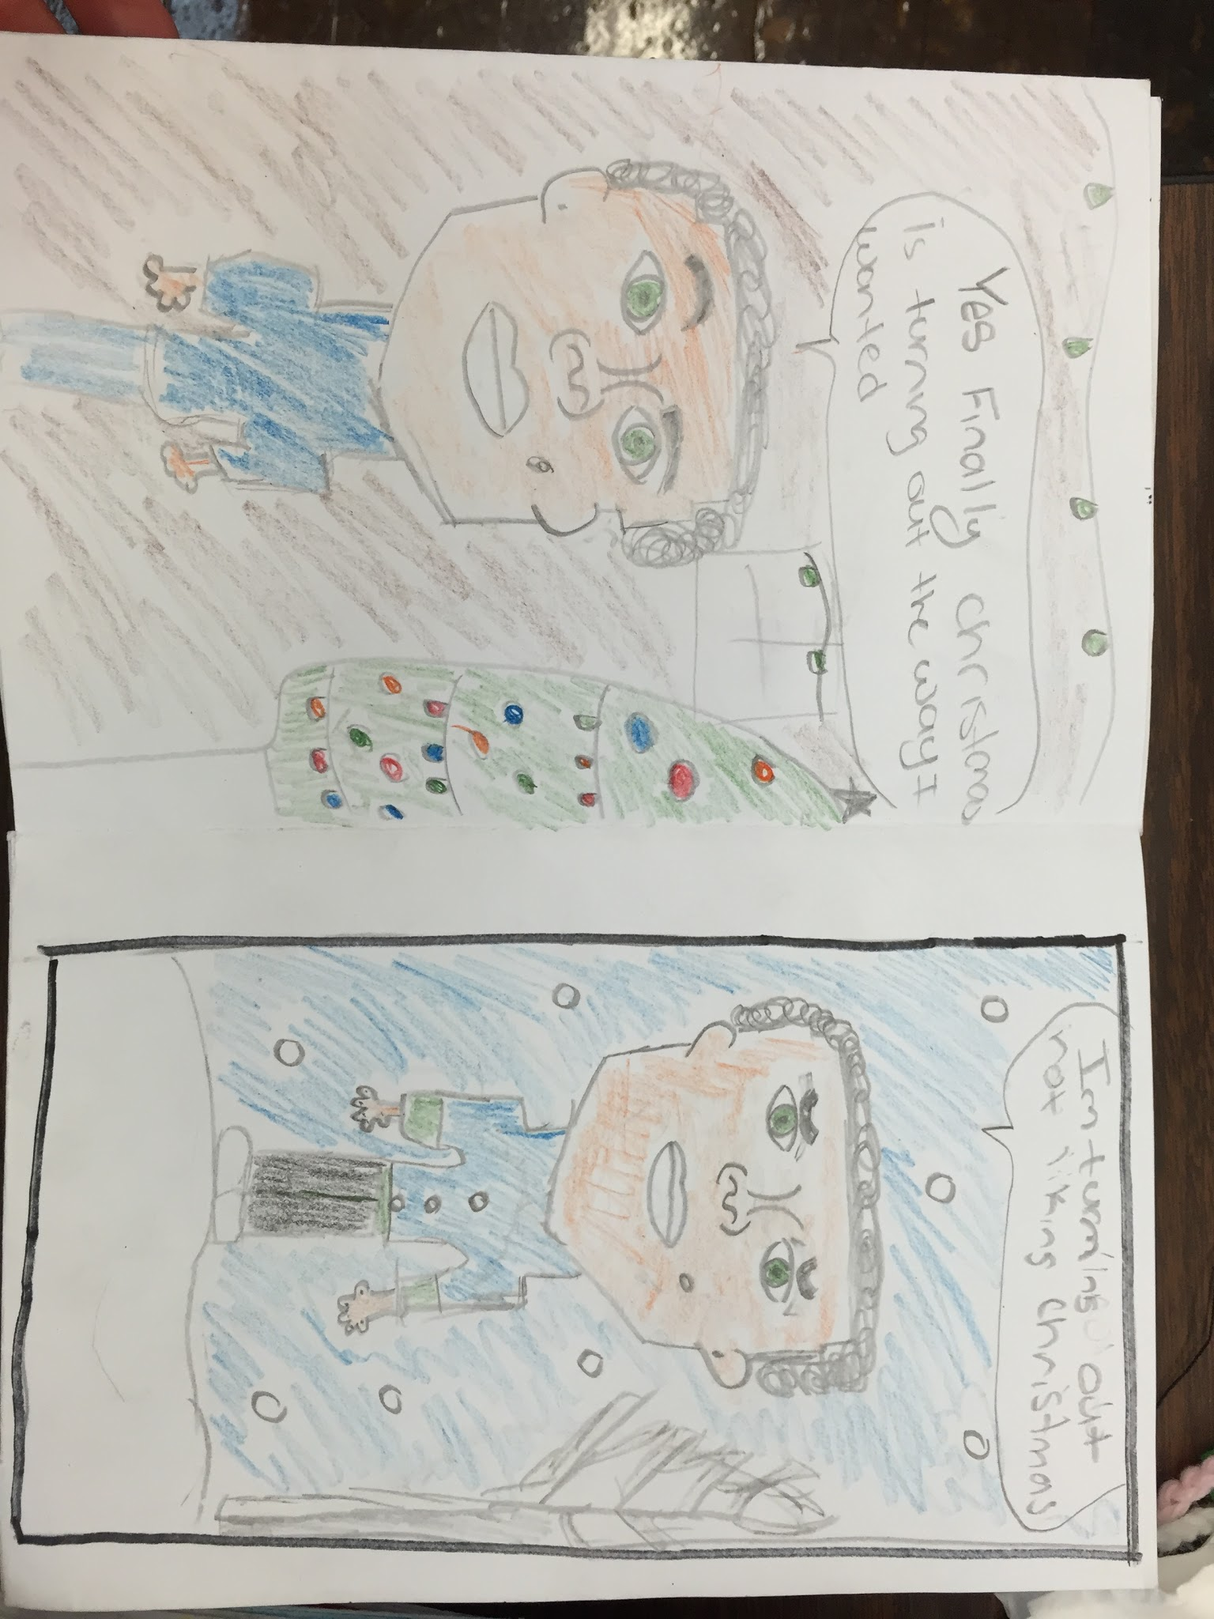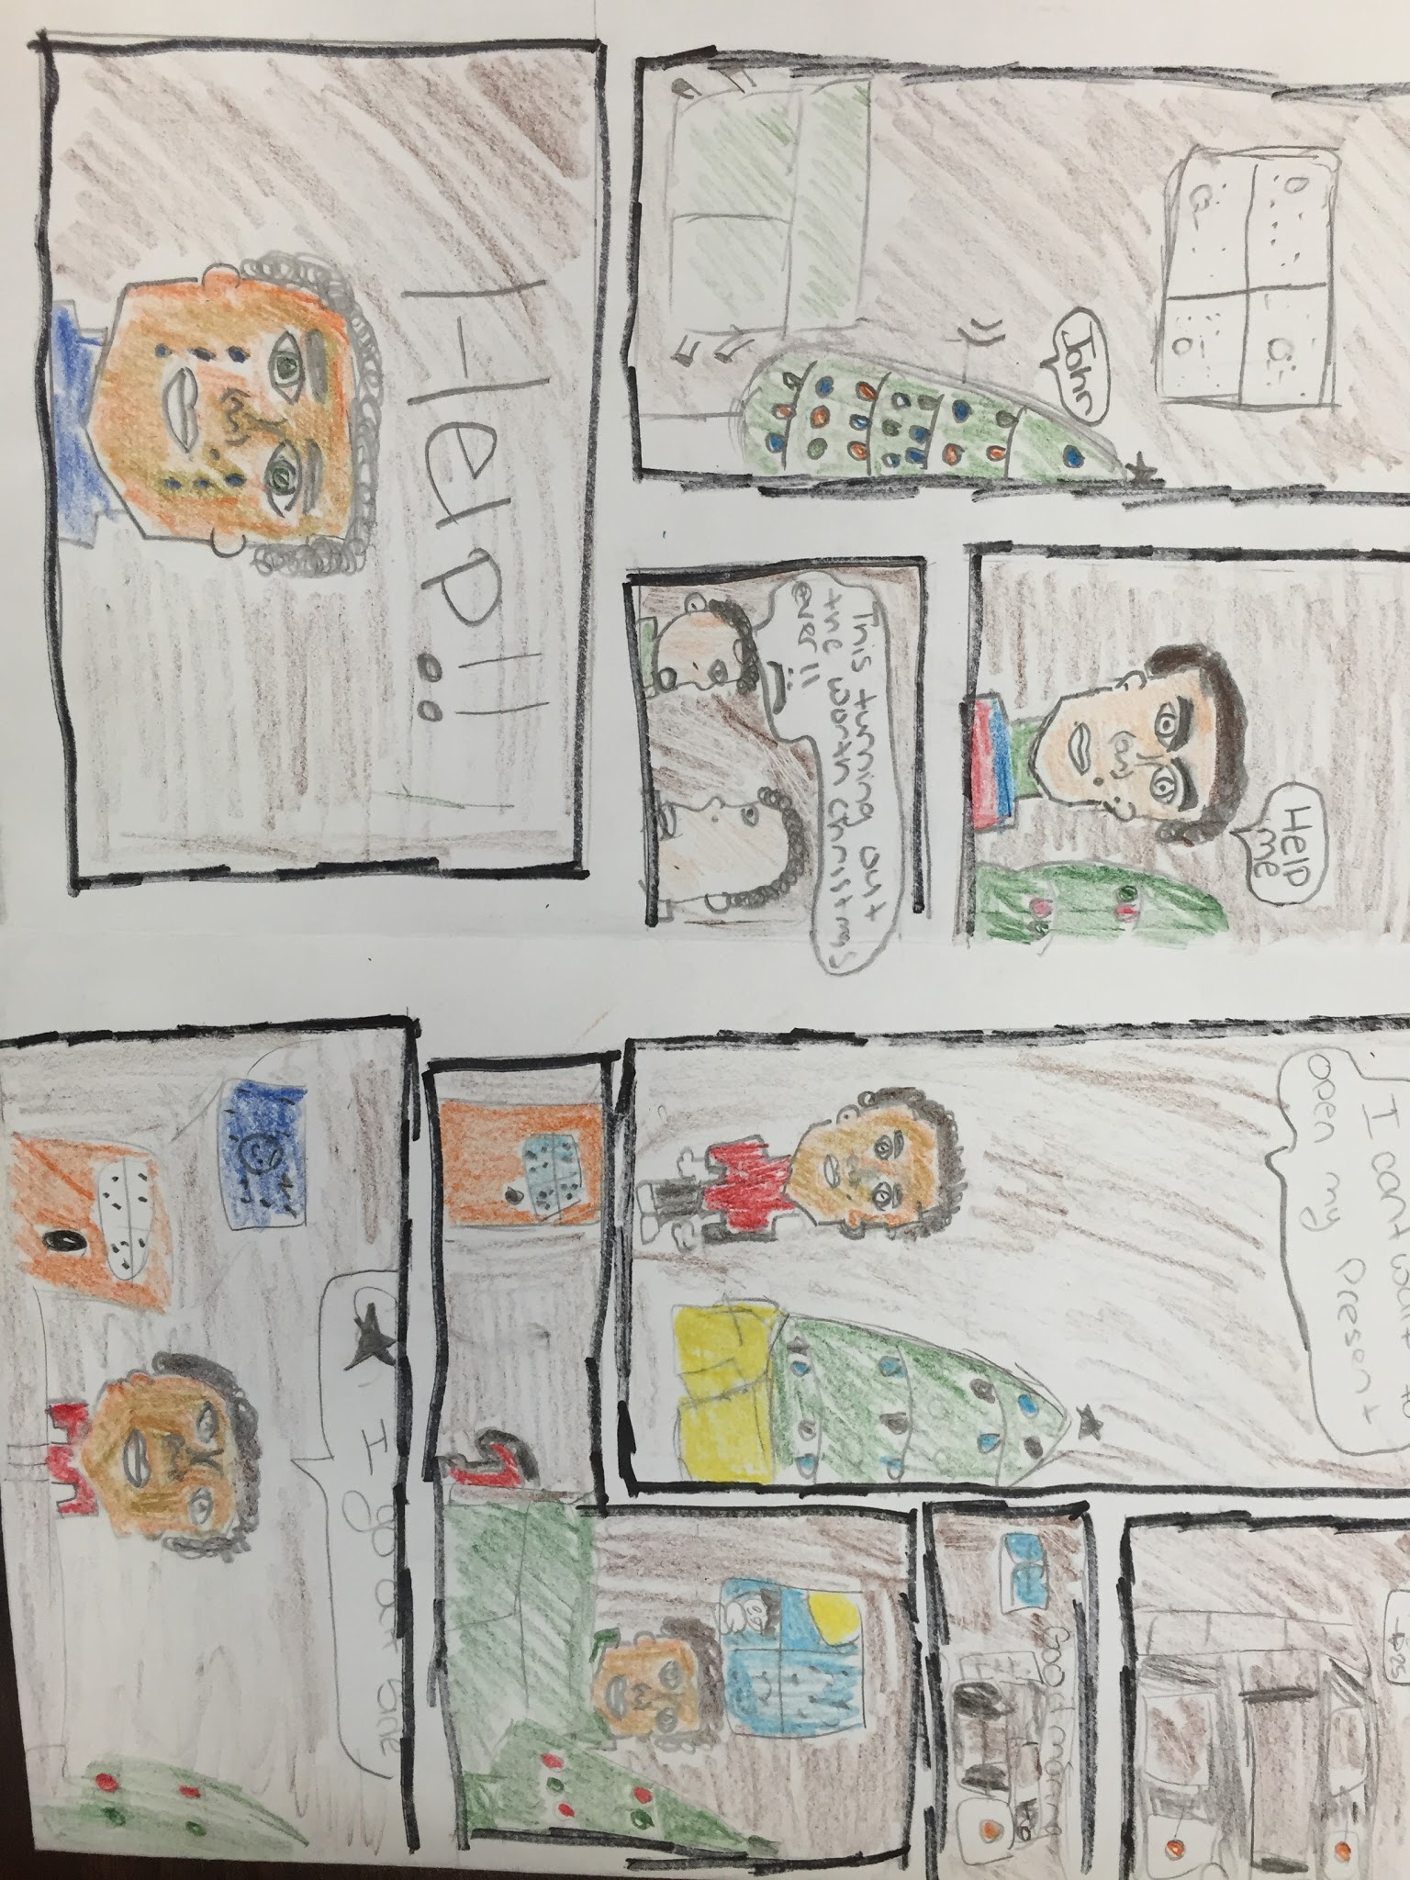
This student received an A for the final project grade. He/she included every requirement on the rubric, and was creative in his/her use of the medium. He/she used the knowledge of figure and facial illustrations to add an element of emotion and expression to his/her artwork.
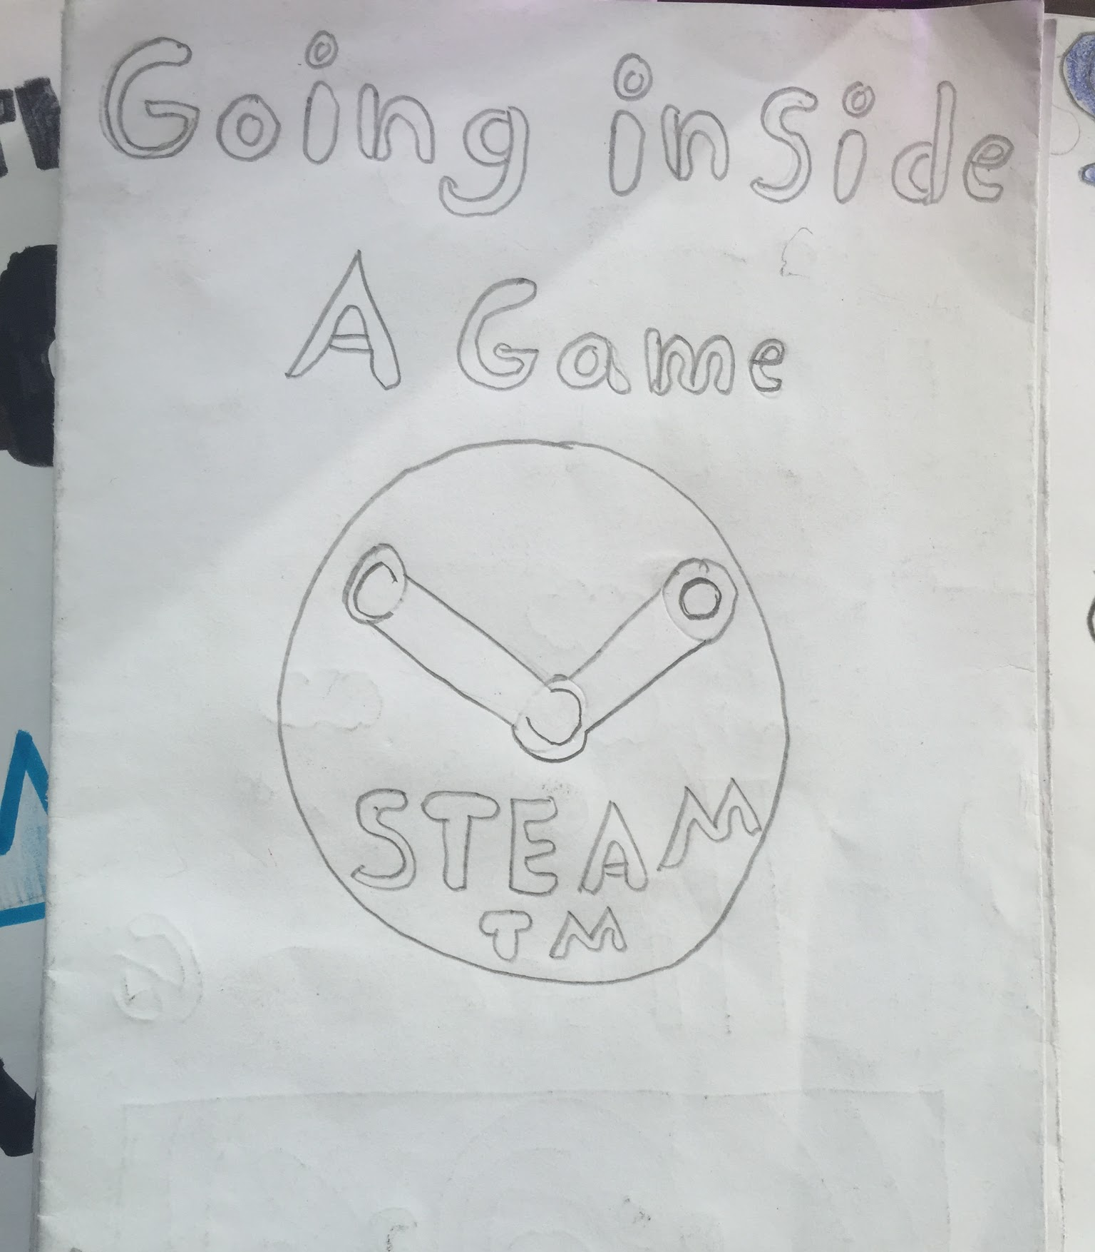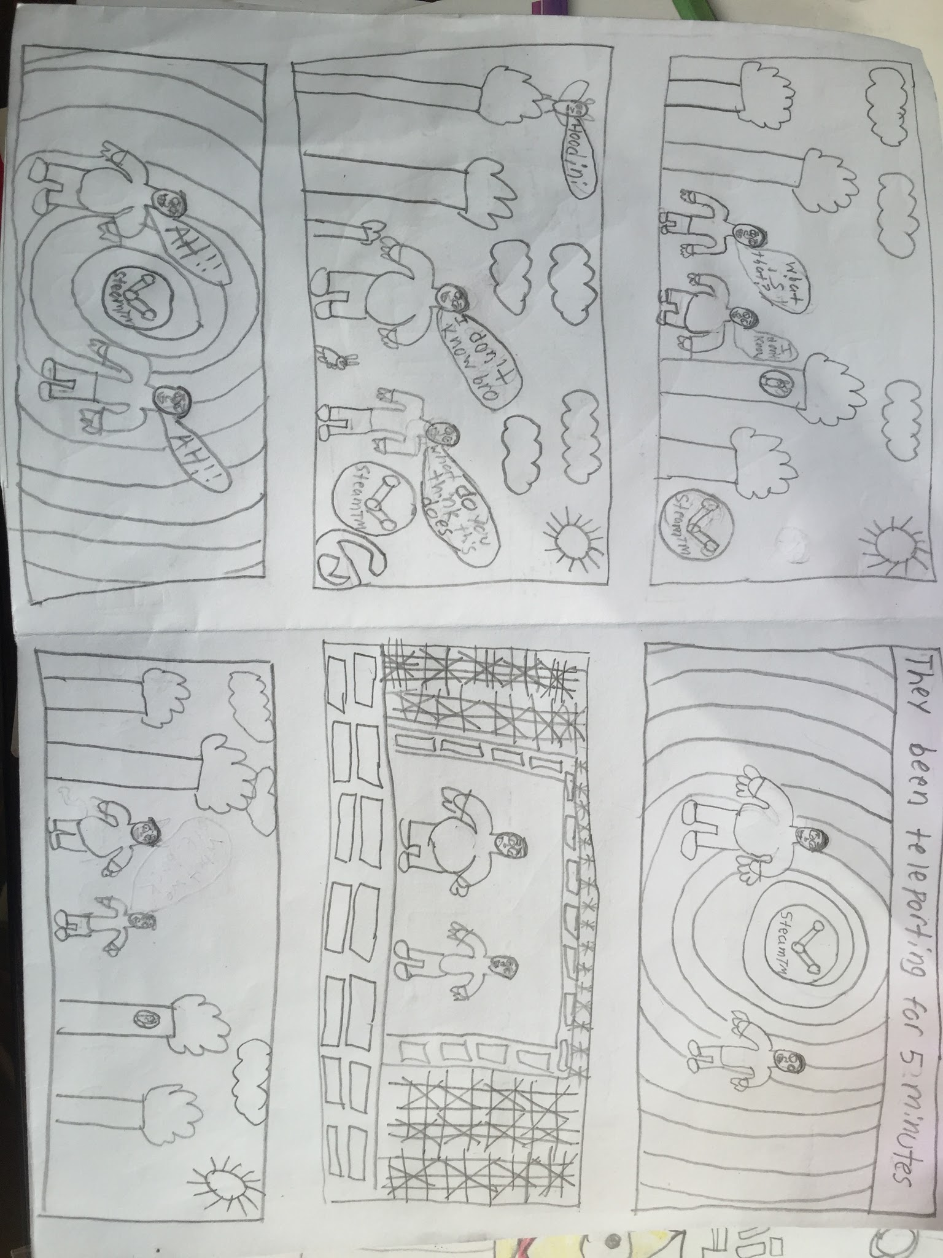
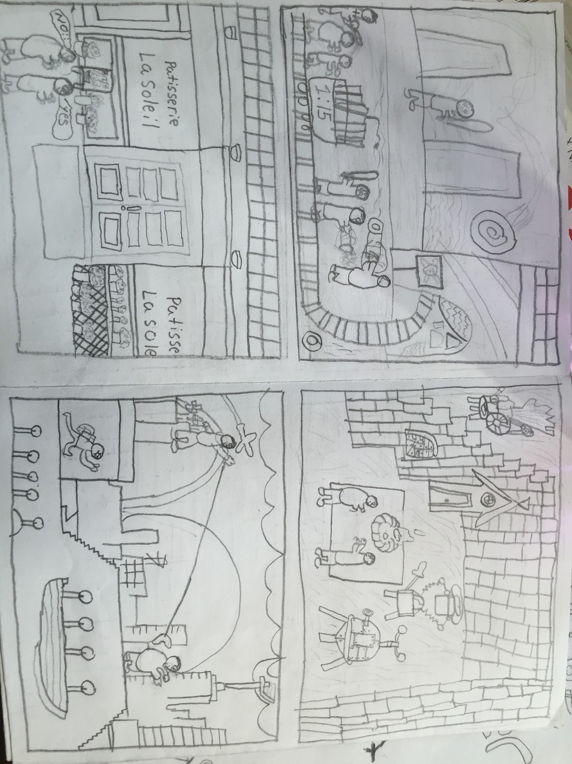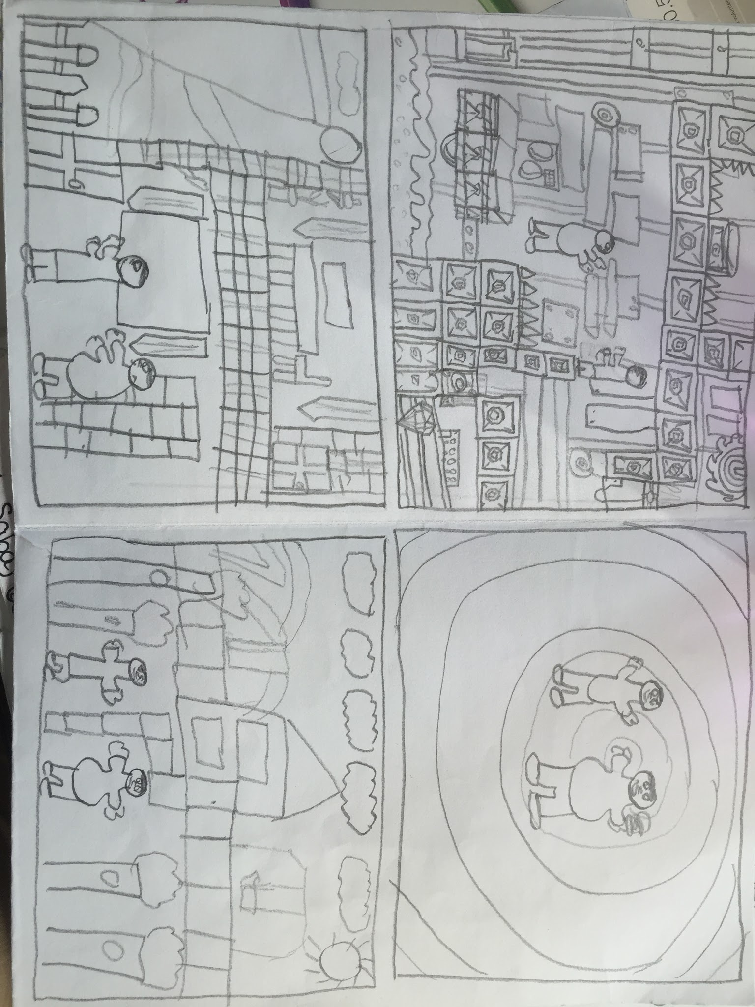
Although this work is not yet finished, the student clearly is on the way to receiving an excellent grade. An example of the work from one of the students with special needs, this student began the project not performing well. The student was off task and lacked focus, however after finally getting a solid foundation for an idea, the student exceeded all expectations. The figurative drawing isn’t completely accurate, however the student is clearly spending time on the illustrations and completing them with great care. The student included all elements from the rubric.

AVERAGE (B)
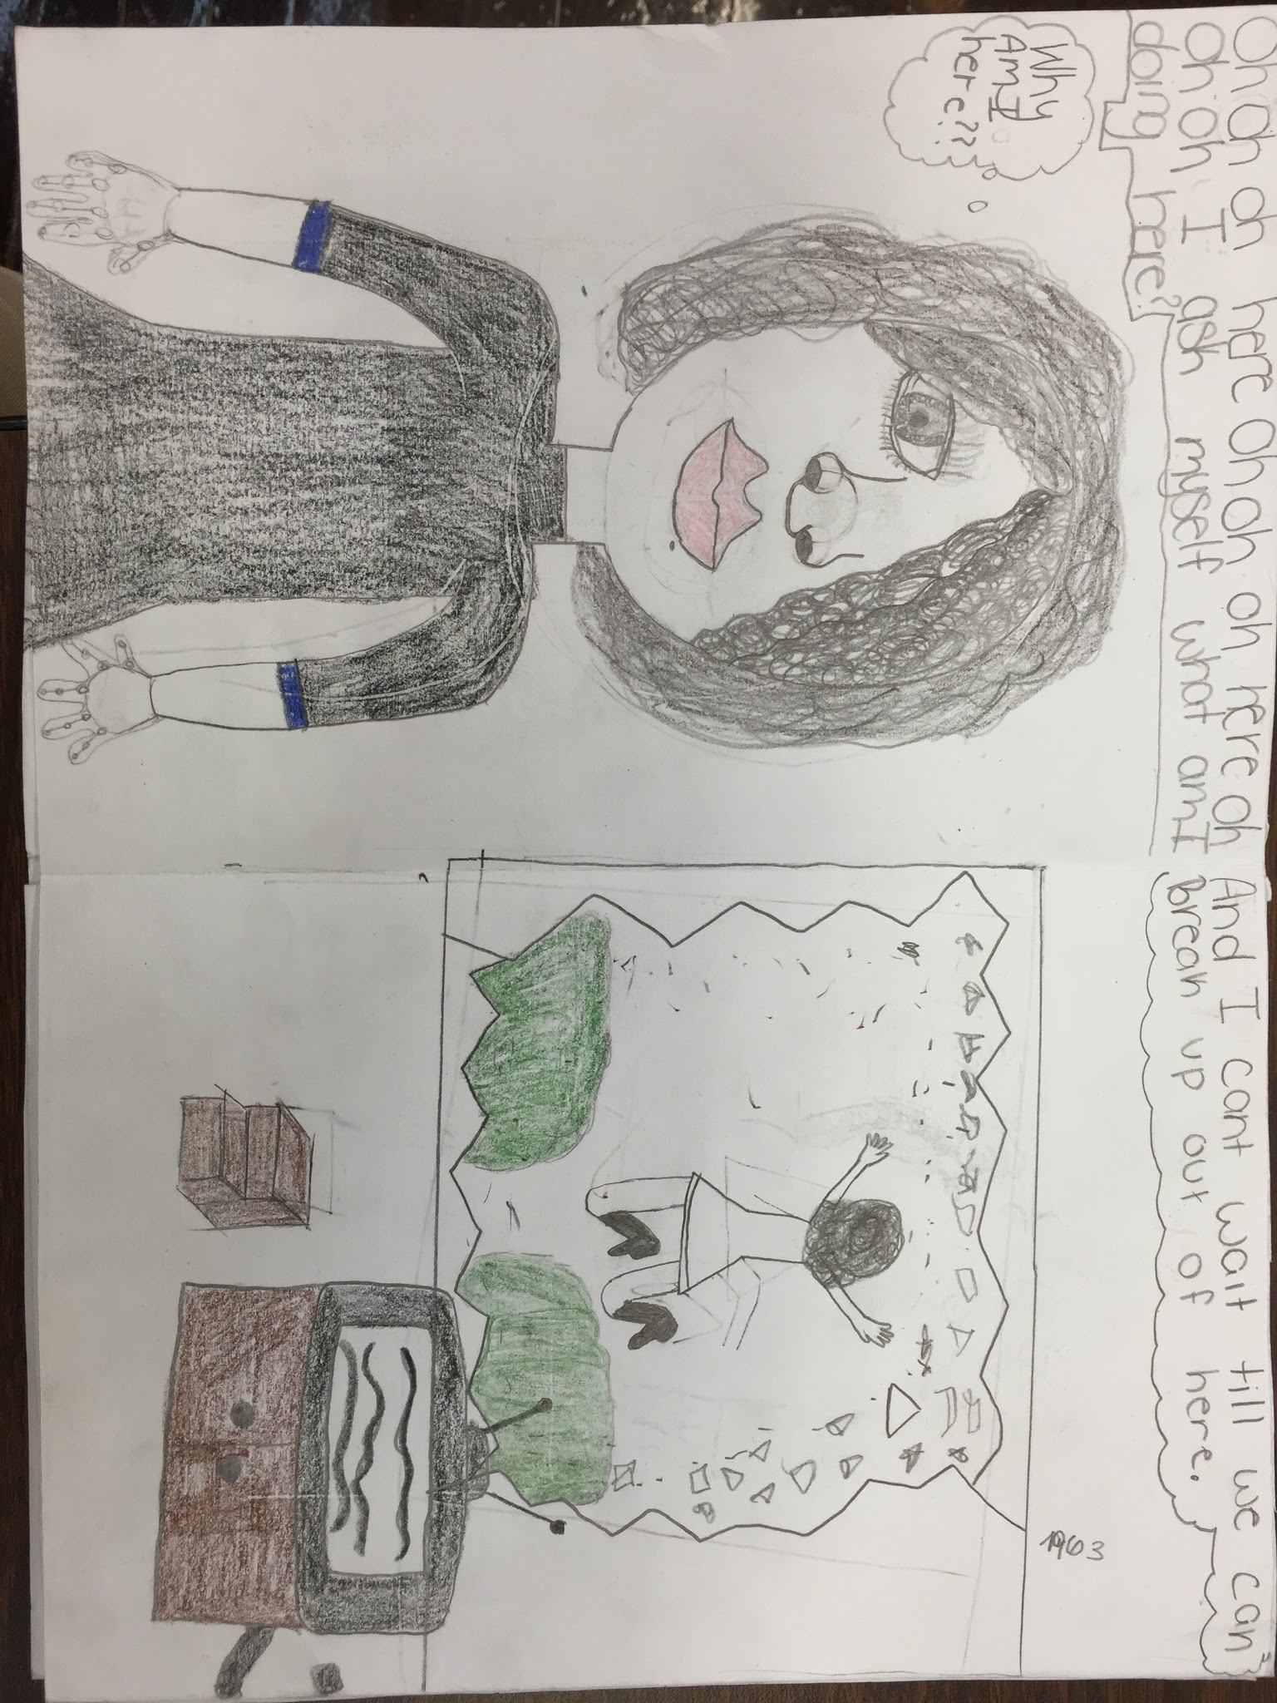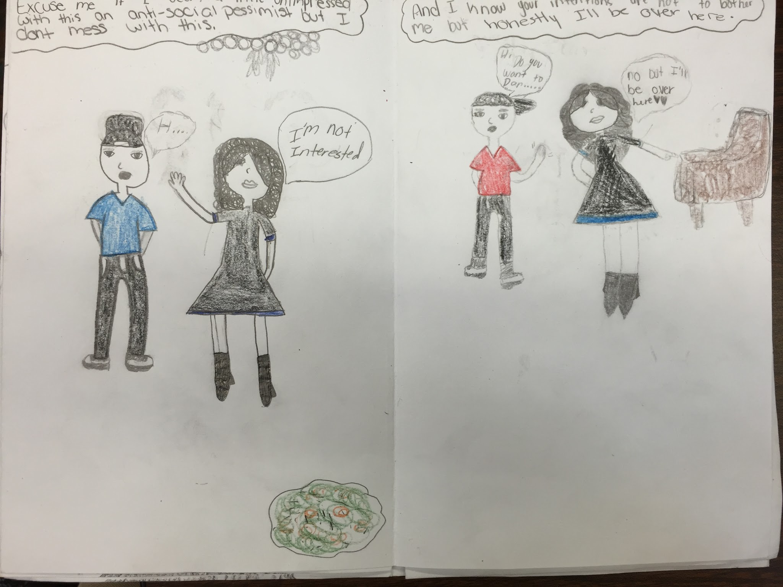
This student received a passing but average grade. They did not follow all of the rules on the rubric (specifically the one that states they must incorporate different size and shape panels to help with their story). Their use of the human figure is effective and mostly accurate, however the facial features do not exhibit new knowledge on how to draw features.

BELOW AVERAGE (C OR LOWER)
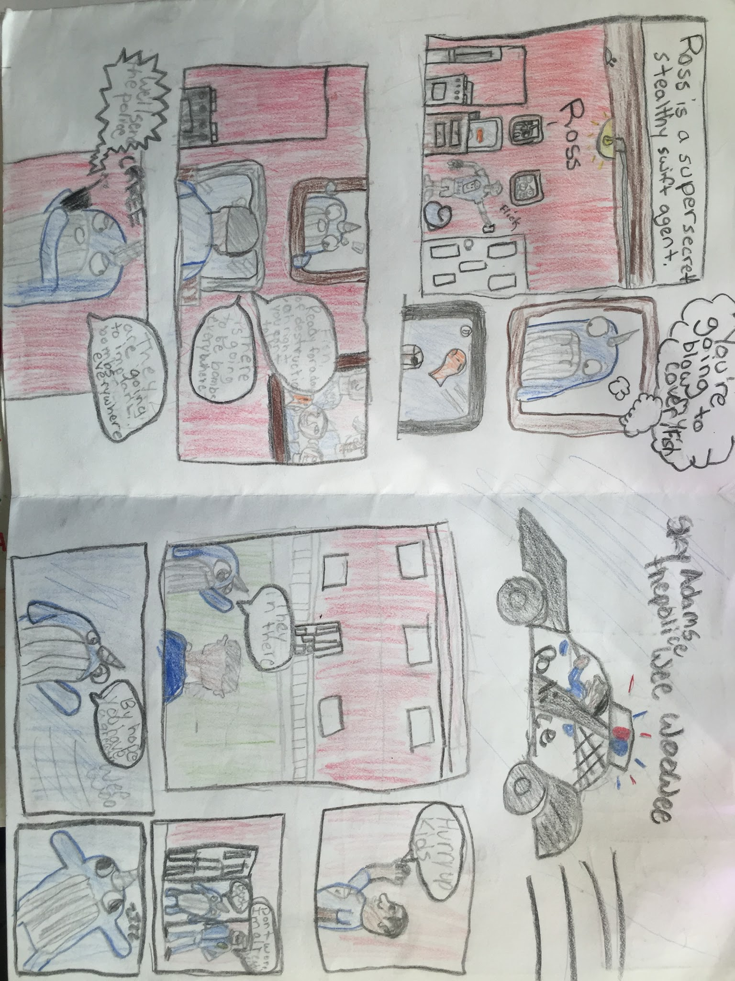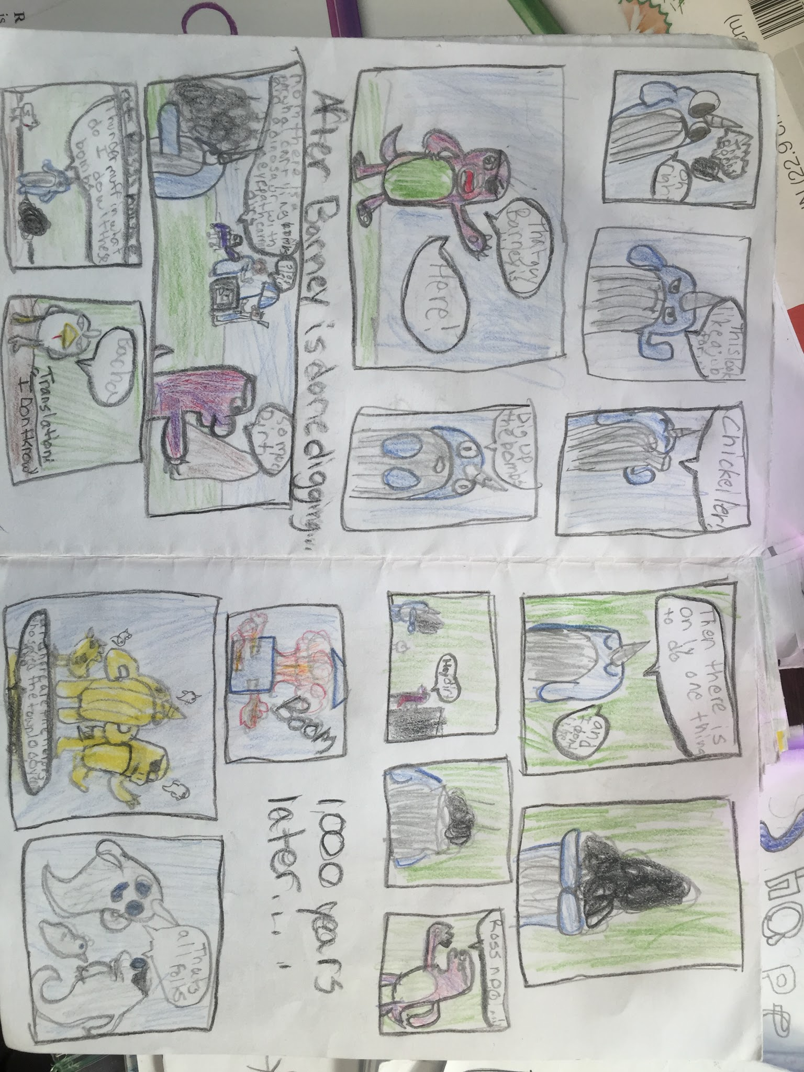
Although the student did his/her best to create a narrative work of art in the comic book style, the student relied heavily on the use of a Narwal, rather than a human, for their illustrations. The student rarely included any human figure drawing in his/her book. The student also appears to have rushed through the final coloring stages of the story, resulting in a work that is not carefully orchestrated.

