I. OVERVIEW
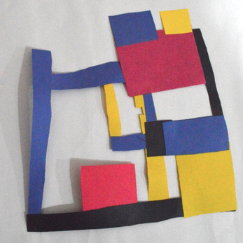

LESSON TITLE: Mondrian Mobiles
LESSON SUMMARY: In this lesson, students will be examining the work of Piet Mondrian. They will gain inspiration and knowledge from his use of primary colors and basic shapes to create a construction paper representation of a room in their home.

TEACHER(S) NAME: Taylor Hughes
GRADE LEVEL: 1st Grade
CLASS NAME: Grade 1 Art CLASS SIZE: 15-21 Students
CLASS TIME/DATE: 60 Minutes 1 Days/week 4 Total Session(s)/Days

A. BIG IDEA:
Abstraction of Ideas

B. ENDURING UNDERSTANDINGS:
Abstraction of ideas refers to the concept of being able to reflect emotionally and visually on any aspect of life. It allows for the opportunity to reflect on a thought, vision, emotion, feeling, memory, etc. and turn it into something much more meaningful and thought-provoking. By being able to abstract our ideas, we are able to understand ourselves on a deeper level and express complex thoughts to a larger audience. In the realm of art, artists are often given the opportunity to express thoughts, emotions, and ideas representationally or non-representationally - abstraction falls into the latter category. This allows for artists to use elements of art and principles of design to visually express ideas in ways that may not be immediately apparent to viewers, but are nonetheless incredibly important.

C. ESSENTIAL QUESTIONS:
- What are primary colors?
- What is a shape?
- What is abstraction?
- What is abstraction in artmaking?
- Why is it important to discuss abstract art?

D. BACKGROUND INFORMATION
Prior to this lesson, the first grade students are expected to be able to properly identify their colors, and some of them may or may not know which colors are the primary colors. They should be able to properly use scissors on their own, and should be able to trace manipulatives with a pencil. They should be able to use a ruler to draw straight lines.

E. MATERIALS/EQUIPMENT, ROOM ARRANGEMENT
1. MATERIALS/EQUIPMENT:
- PowerPoint and Slideshow
- Drawing Pencils
- Construction Paper - Red, Blue, Yellow, and Black
- Markers
- Scissors
- Glue sticks
- Rulers
- Square and Rectangle manipulatives
- Sketchbooks
2. ROOM ARRANGEMENT:
- The room will be arranged so that students sit in groups at tables, with a maximum of 6 students at a table. All students will have a clear view of the projector at the front of the room. There are two stations of materials on either side of the room, each stocked with markers, colored pencils, scissors, and glue, so that traffic to retrieve their own materials is not an issue. There are also center units at each table; containing small but sufficient amounts of markers, colored pencils, drawing pencils, pencil sharpeners, and erasers.

F. VOCABULARY and REFERENCES/SOURCES
- VOCABULARY:
  - Primary colors - red, yellow, and blue. Colors that cannot be created by the mixing of any other hues.
  - Abstract Art - art that does not attempt to represent external reality, but seeks to achieve its effect using shapes, forms, colors, and textures.
  - Shape - An element of art that is limited to two-dimensions (height and width).
  - Line - An identifiable path created by a point moving in space. It is one-dimensional and can vary in width, direction, and length.
  - Representin’ - Proclaiming one’s identity and affiliations
- REFERENCES/SOURCES:
  - http://www.biography.com/people/piet-mondrian-9411728
  - 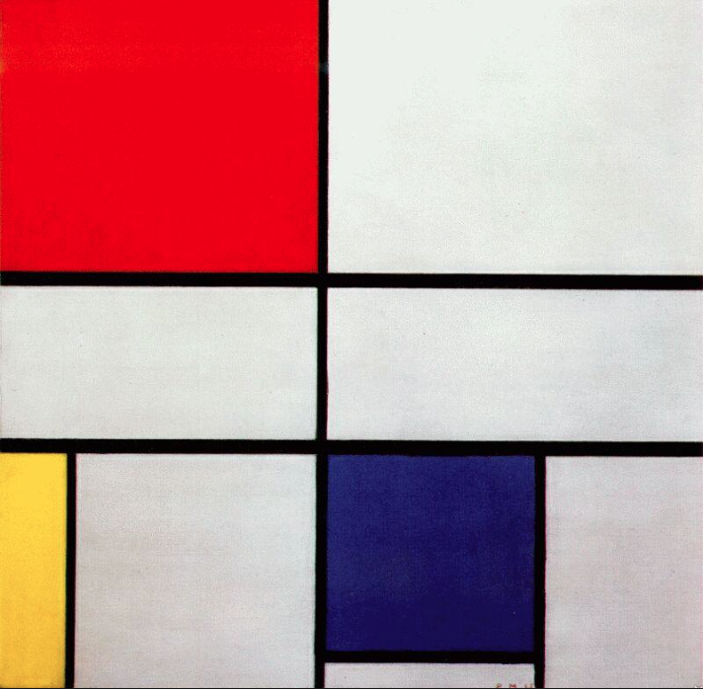Piet Mondrian, Composition C, 1920, Oil on canvas. 2’x2’

II. OBJECTIVES and STANDARDS

A. OBJECTIVES:
- The students will be able to exhibit an understanding of primary colors through class discussion.
- The students will be able to examine the work of Piet Mondrian and discuss his use of color, shape, and line.
- The students will be able to display an understanding of abstraction by using basic shapes to represent a room in their house.
- The students will be able to create a construction paper mobile composed of primary colors and shapes.

B. STANDARDS
ART STANDARDS:
- NJCCC ART:
  - 1.1.2.D.1: Identify the basic elements of art and principles of design in diverse types of artwork.
In this lesson, students will be examining the work of Piet Mondrian and identifying line, color, and shape throughout the different examples.
  - 1.3.2.D.1: Create two- and three-dimensional works of art using the basic elements of color, line, shape, form, texture, and space, as well as a variety of art mediums and application methods.
In this lesson, students will be creating a two-dimensional mobile using construction paper, focusing their work on the use of primary colors, shape, and line.
  - 1.3.2.D.3: Employ basic verbal and visual art vocabulary to demonstrate knowledge of the materials, tools, and methodologies used to create and tell visual stories.
In this lesson, students will be discussing their work over the course of the assignment and at its culmination, and demonstrating an understanding of how to properly use the tools and materials in the art room.
- NJCCC NON-ART SUBJECT:
  - CCSS.MATH.CONTENT.1.G.A.2: Compose two-dimensional shapes (rectangles, squares, trapezoids, triangles, half-circles, and quarter-circles) or three-dimensional shapes (cubes, right rectangular prisms, right circular cones, and right circular cylinders) to create a composite shape, and compose new shapes from the composite shape.
In this lesson, students will be creating a composition using rectangles, lines, and squares.
- National Core Visual Arts Standards (NCCAS):
  - VA:Cr1.1.1: Engage collaboratively in exploration and imaginative play with materials.
In this lesson, students will be working at their tables and discussing their
work with their classmates throughout the process, engaging collaboratively
to share materials.
III. LEARNING EXPERIENCE

A. INTRODUCTION:
DAY 1
- Hook: The students will walk into the classroom and be instructed to sit in their seats. There will be nothing on their tables, but there will be a basic color wheel on the projector screen.
- Topic Question or Introductory Activity (Pre-Assessment): Students will be asked to identify the colors on the color wheel, and will be asked which colors are the primary colors. They will then be shown Composition C by Piet Mondrian, and will be asked to talk about what they see.
  - What colors do you see? What shapes do you see?
  - What do you think this is a picture of? What kind of artwork is it?
- Students will then be shown Broadway Boogie Woogie by the same artist. They will be asked to discuss what the painting is representing. Some students will make up images of what they think it could be - some will talk about how it looks like a train station or a city.
  - Piet Mondrian used only red, yellow, blue, and white to make this painting, but it looks very complex and like it could represent a specific scene. How did he do that? Why is it so interesting to think about?
- Introduction of big idea: How can we use only primary colors and basic shapes to represent our ideas?
B. SEQUENCE OF ACTIVITIES/ORGANIZER
DAY 1 continued
- The teacher will then request student volunteers to help pass out their sketchbooks. The students will spend the remainder of the class sketching a work of art that resembles that of Piet Mondrian.
- “I want everyone in this room to think of themselves as an artist. Pretend that Mr. Mondrian just contacted your teacher and asked for help for an upcoming art show he is putting on in the museum. He needs to add some paintings to his collection, and asked if we would help him and be a part of his art show. If you were to make a painting to put in a show with Mr. Mondrian, what would it look like?”
- “What colors will we use for our paintings? What kinds of shapes will we use?”
- At this point, the instructor will pass out pencils and markers to the students. Although the students should only use red, blue, yellow, and black markers, they will be given an assortment of other colors as well to assess their knowledge on which colors they should and should not be using.
- The instructor will remove the example of Mondrian’s work from the screen so that students are not inclined to copy his work directly.
- Students will spend the rest of the class drawing in their sketchbooks. Instructor will circulate throughout the room, answering independent questions as needed.
- Conclusion: Students will be instructed to begin cleaning up with 7 minutes left in class. They will be told to organize their center units (storage for the markers, pencils, etc.) according to the picture at their tables. They will be asked to sit quietly in their seats when they think they are finished, and will be dismissed when their homeroom teacher comes to pick them up. They will line up at the door before exiting the classroom.
DAY 2
- Introduction/Warm-Up: Prior to students arrival, the instructor will place sketchbooks at specific seats. When the students arrive in class, they will line up outside the door. When they are quiet, they will enter the room and be instructed to sit at the seat by their sketchbook. When all students are seated, they will be asked to make a drawing in their sketchbook using only primary colors. The subject is their choice, but they can only use the primary colors. The instructor will not tell students what the primary colors are as a way to test their retention of knowledge from the previous class. (10 minutes).
  - After 10 minutes, students will be told to put all drawing materials back in their center units and will direct attention to the projector, where Composition C by Piet Mondrian will be on display. The instructor will ask what students remember about this work of art.
    - “What colors do you see? What shapes did the artist use? Why is this important?”
  - Students will then be shown Broadway Boogie Woogie by Piet Mondrian.
    - “What is this a painting of? What does it remind you of?”
    - “What did Piet Mondrian use to represent his ideas?”
    - “Is this realistic or abstract? Why?”
- Artmaking Activity
  - Teacher will then show students her example for the artmaking activity.
  - “For this project, we will be thinking of a room in our house in terms of very simple shapes and colors”
  - “What kinds of shapes can we use to represent different parts of our room?”
  - Instructor will use red, blue, and yellow markers on the dry erase board to begin drawing the shapes that the students discuss for their bedrooms, drawing rectangles and squares for a bed, table, rug, etc. It will begin to resemble the compositions by Piet Mondrian.
- Demonstration
  - Teacher will then show students how they will assemble their construction paper compositions. Teacher will have students gather around a center table to observe how to properly use scissors, trace the square and rectangle manipulatives, and assemble their pieces of paper together to represent the placement of objects in their rooms.
  - Teacher will tell students that they should return to their seats. The instructor will ask one student to pass out glue sticks to the tables - students will have to share glue sticks (1 glue stick for every 2 students). Instructor will ask another student to pass out scissors, and instructor will pass out one piece of each colored paper to each student, as well as the square and rectangle manipulatives.
  - Students will begin working on their projects for the remainder of class. Instructor will monitor student progress and behavior by circulating around the room, and will address questions/concerns as they arise independently.
- Conclusion: Students will be instructed to begin cleaning up with 7 minutes left in class. They will be told to organize their center units (storage for the markers, pencils, etc.) according to the picture at their tables. All large scraps of paper as well as works in progress will be stored in their sketchbooks. Smaller scraps will be collected in the “Scrap Paper” bin. They will be asked to sit quietly in their seats when they think they are finished, and will be dismissed when their homeroom teacher comes to pick them up. They will line up at the door before exiting the classroom.
DAY 3
- Introduction/Warm-Up: Prior to students arrival, the instructor will place sketchbooks at specific seats. When the students arrive in class, they will line up outside the door. When they are quiet, they will enter the room and be instructed to sit at the seat by their sketchbook. They will be instructed to make a drawing of any subject of their choosing, however they make only use squares and rectangles to create their drawing. (15 minutes)
  - Teacher will circulate the room as students are working.
- After 15 minutes, students will be instructed to close their sketchbooks and put away drawing materials in their center units, and direct their attention to the front of the room. Teacher will bring out her example for the artmaking activity, and ask a student to volunteer to describe what the assignment is.
- “What colors are we using?”
- “What are we representing? What shapes are we using to represent different objects in our rooms?”
- Students will then volunteer to help pass out supplies (scissors and glue). If students decide to use rulers, they may retrieve them themselves.
- As students are working, instructor will put examples of Piet Mondrian’s work on the projector for inspiration.
- Conclusion: Students will be instructed to begin cleaning up with 7 minutes left in class. They will be told to organize their center units (storage for the markers, pencils, etc.) according to the picture at their tables. All large scraps of paper as well as works in progress will be stored in their sketchbooks. Smaller scraps will be collected in the “Scrap Paper” bin. They will be asked to sit quietly in their seats when they think they are finished, and will be dismissed when their homeroom teacher comes to pick them up. They will line up at the door before exiting the classroom.
DAY 4
- Introduction/Warm-Up: Prior to students arrival, the instructor will place sketchbooks at specific seats. When the students arrive in class, they will line up outside the door. When they are quiet, they will enter the room and be instructed to sit at the seat by their sketchbook. They will be instructed to make a drawing of the monster that lives under their bed. (15 minutes)
  - Teacher will circulate the room as students are working.
- After 15 minutes, students will be instructed to close their sketchbooks and put away drawing materials in their center units, and direct their attention to the front of the room. Teacher will bring out her example for the artmaking activity, and ask a student to volunteer to describe what the assignment is.
- “What colors are we using?”
- “What are we representing? What shapes are we using to represent different objects in our rooms?”
- Students will then volunteer to help pass out supplies (scissors and glue). If students decide to use rulers, they may retrieve them themselves.
- Students will continue to work on and ultimately finish their projects, seeing as most students were near finishing.. When there are 15 minutes left in class, students will clean up all materials according to procedure.
C. CLOSURE/CULMINATING EXPERIENCE
DAY 4
- After cleaning up, students will gather together on the carpet at the side of the room, with their finished projects. Instructor will ask one student at a time to volunteer to stand up in front of the room with their finished work. The instructor will ask students to answer the following questions:
  - “How would you describe your work? What did you use to represent your ideas? What kind of artwork is this? If you could change anything about either how you worked on this project or how it turned out at the end, would you? What would it be?”
- Instructor will then ask the student’s classmates to answer the following questions:
  - “What do you notice about this work? What is one of the most successful parts? How would you describe this artwork to someone who cannot see it? Do you think this student should do anything differently to improve if they were to make this project again?”
- Instructor will ask the following questions for anyone in the class to answer:
  - “How does our work relate to that of Piet Mondrian? How is it different? What was different about using only shapes and colors to represent our ideas?”
- After a few students volunteer to speak about their work, the teacher will bring the students down to the front of the school to display their work in the designated display case.

D. ADAPTATIONS/MODIFICATIONS
- Adaptations and Modifications:
- English as an additional/second language (EAL/ESL): For students who do not speak English as a first language, the teacher will rely heavily on visual demonstrations and peer leaders for success. The teacher will make sure that every step of the process is shown in a hands-on demonstration, so that the student may be able to follow along visually. The teacher will be sure to point to the examples by Piet Mondrian on the board, and then point to the teacher examples when working with the student one-on-one. In order to help the student to begin to understand some important art vocabulary (mostly classroom supplies and colors - scissors, shapes, colors, etc.), the teacher will repeat the vocab word when pointing to what it is. For example, when discussing the color red, the instructor will point to the red paper.
- Hearing impaired students: Students who are deaf or partially deaf will rely on visual instruction in order to succeed. The instructor will point to the tool the student should be using and will physically show them how to use it - for example, when showing them how to use the scissors, the instructor will hold up the scissors and the paper, and show the student how to properly use them. The instructor will also show the student how to properly trace the square and rectangle manipulatives, and how to assemble the piece. Because the student are so young and may not be able to read, the instructor cannot rely on written instructions for the student.

- Differentiated Instruction:
- Visual learners: In-class demonstrations
- Interpersonal learners: Opportunity to work with and talk to classmates during work time
- Bodily-kinesthetic learners: Can move around the room to work in a location that best suits their comfort (within reason)
- Intrapersonal learners: Will benefit from the reflection at the end of the activity, in which the students are asked to discuss their own experience working on the project.
- Students will be given various amounts of teacher support throughout the lesson - in the beginning, the instructor will be showing the students step-by-step what to do, and will circulate the room as students are working. Students will have the opportunity to work independently without the teacher “hovering”, so long as they are using materials properly and appropriately.

IV. LESSON ANALYSIS

A. STUDENT ASSESSMENT
1. Pre-Assessment: Students will be assessed on their knowledge of abstract art and primary colors through the preliminary class discussion.

2. Formative Assessment: Students will be formally assessed through the first two warm-up drawings in their sketchbooks and by their daily performances every day (use of shape, ability to articulate their thought process as the teacher talks to students individually, etc.)

3. Summative Assessment: Rubric

Criteria/Objective | Exemplary (A) | Good (B) | Satisfactory (C) | Needs Improvement
The student will examine ABSTRACTION by observing the work of Piet Mondrian and designing an artwork based off of the layout of a room in their house. | The artwork resembles a strong influence from Piet Mondrian. The student clearly observed the most important characteristics of Mondrian’s work and adapted it into his/her own practice. | The artwork resembles an influence from Piet Mondrian. The student observed the most important characteristics of Mondrian’s work and adapted it into his/her own practice. | The artwork resembles a partial influence from Piet Mondrian. The student somewhat observed the most important characteristics of Mondrian’s work and attempted to adapt it to his/her own practice. | The artwork does not resemble an influence from Piet Mondrian. The student did not observe the most important characteristics of Mondrian’s work and did not attempt to adapt it to his/her own practice.
 | The student creatively incorporated the layout of a room in their own house into their artwork, and was able to verbally explain each part of their work and how it represented their room. | The student incorporated the layout of a room in their own house into their artwork, and was able to verbally explain each part of their work and how it represented their room. | The student attempted to incorporate the layout of a room in their own house into their artwork, and was somewhat able to verbally explain each part of their work and how it represented their room. | The student did not attempt to incorporate the layout of a room in their own house into their artwork, and was unable to verbally explain each part of their work and how it represented their room.
 | The student actively participated during discussions in class. The student demonstrated firm knowledge about abstraction and Piet Mondrian. S/he raised hand to contribute insightful knowledge. | The student participated during discussions in class. The student demonstrated knowledge about abstraction and Piet Mondrian. S/he raised hand to contribute insightful knowledge. | The student occasionally participated during discussions in class. The student demonstrated knowledge about abstraction and Piet Mondrian. S/he raised hand to contribute knowledge. | The student rarely participated during discussions in class. The student failed to demonstrate knowledge about abstraction and Piet Mondrian. S/he raised hand to contribute knowledge.
The student will use and identify PRIMARY COLORS by creating an artwork {and engaging in an oral art critique}. | The student successfully used only the primary colors in not only their finished artwork but in their sketchbook drawing from Day 2. . | The student used the primary colors in their finished artwork and/or their sketchbook drawing from Day 2. | The student used only the primary colors in their finished artwork but when given more color options, strayed from the use of just the primary colors. | The student did not show any discipline in color choice.
 | During class discussions and final critique, the student was able to consistently identify the primary colors. | During class discussions and final critique, the student was able to identify the primary colors. | During class discussions and final critique, the student was sometimes able to identify the primary colors. | During class discussions and final critique, the student was unable to identify the primary colors.
The student will demonstrate an understanding of cutting, tracing, and pasting in the final artwork. | The student showed extreme care in cutting out each piece of their finished composition. It extremely neat. | The student showed care in cutting out each piece of their finished composition. It is neat. | The student showed some care in cutting out each piece of their finished composition. It is fairly neat. | The student showed little to no care in cutting out each piece of their finished composition. It is very messy.
 | All pieces of the finished composition are securely and properly adhered to each other. The use of glue is very neat and appropriate. | Most of the pieces in the finished composition are securely and properly adhered to each other. The use of glue is appropriate. | Some of the pieces in the finished composition are securely and properly adhered to each other. The use of glue is somewhat appropriate. | Almost none of the pieces in the finished composition are securely and properly adhered to each other. The use of glue is inappropriate.
The student will be able to exhibit an understanding how to visually represent their ideas in an abstract way. | The student clearly referenced a room in their house to represent in their final work, and did so in a very abstract way. The piece does not immediately resemble a specific place, however each piece is clearly derived from an idea. | The student referenced a room in their house to represent their final work, and did so in an abstract way. The piece does not immediately resemble a specific place, however each piece is clearly derived from an idea. | The student attempted to reference a room in their house to represent in their final work, and did so in a somewhat abstract way. The pieces does not immediately resemble a specific place, however each piece seems to be derived from an idea. | The student did not attempt to reference a room in their house to represent in their final work. The piece is not an attempt at abstract art, and does not show evidence of being derived at all from any idea.
Sketches | The student completed and participated in every sketchbook activity. |  |  | The student did not participate in the sketchbook activity.
Total Points or Grade:

Teacher Comments:

B. ASSESSING ARTWORK

- Exemplary (strongest) example:
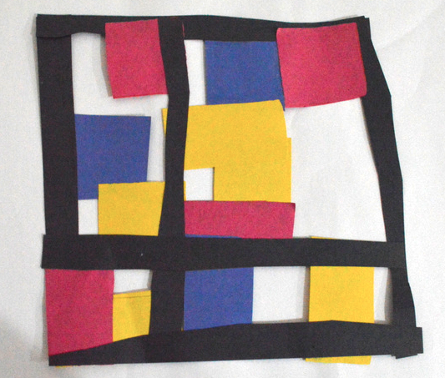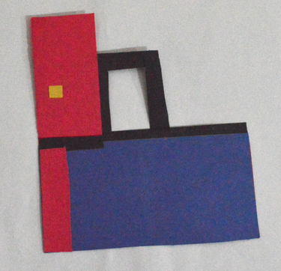
Each of the two students displayed very neat craftsmanship when assembling their pieces. Although the student on the right is unfinished, he/she displayed careful attention to use of shape, skill, space, and color. The student was innovative in his/her use of negative space. The student on the left was extremely neat when assembling his/her piece, used proper shapes and colors, and created an aesthetically pleasing composition that exceeded expectations.
- Great/Good (average) example:
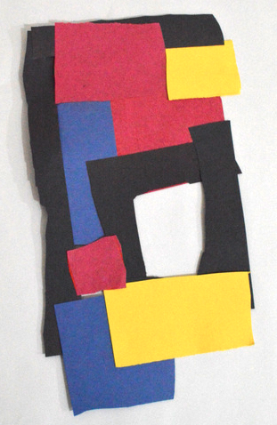
The student neatly assembled all pieces, articulated how his/her piece related to a room, and used correct shapes in the final composition.
- Satisfactory or Unsatisfactory (weakest) example:
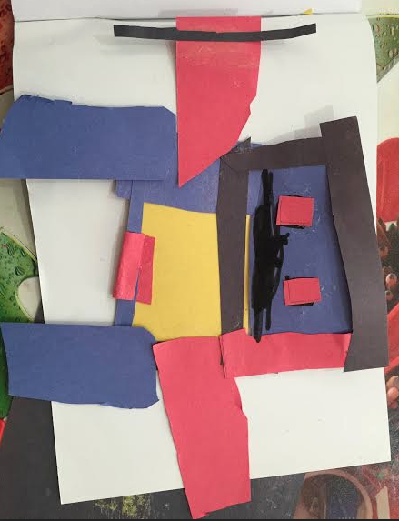
Satisfactory: The student used materials somewhat well, however was clearly trying to create something in a representative way (a robot). He/she listened to the directions in terms of using squares, rectangles, and primary colors, but did not want to use the shapes to represent a room in an abstract way.
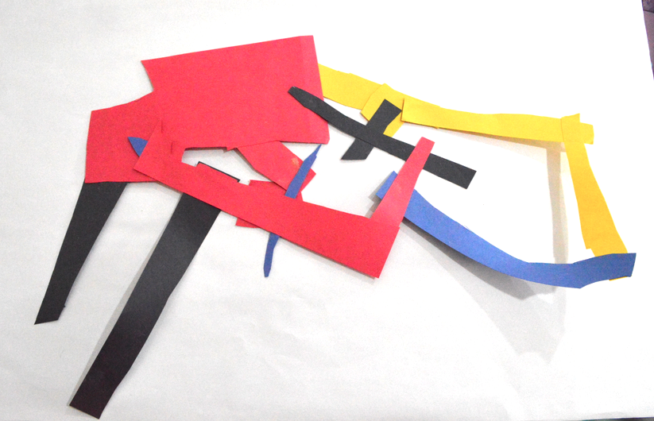
Unsatisfactory: The student did not adhere to directions in terms of using correct shapes. He/she carelessly assembled the final composition and did not display any understanding of how to represent a room in an abstract way.

C. SELF-REFLECTION
When teaching this lesson, there were some aspects of the lesson that I predicted and some things I was extremely surprised about. I was able to anticipate how the students would handle the materials. Because they were only 5 and 6 years old, I predicted that most would be able to use scissors and glue, but would need a lot of demonstration and reminding about how to use the materials properly. I was most surprised, however, about the advanced level of the 1st grade responses to the introductory questioning. Almost all of the students were able to identify the primary colors, and some students were able to perfectly describe what Mondrian was depicting in Broadway Boogie Woogie, with the exception of not knowing exactly what Broadway was, since the majority of the students had spent their entire lives in Italy. The students were able to state that the painting was of “a busy city”, and some of the students guessed that the yellow squares represented cars, and some of the blue and red squares were buildings, as seen from above.
When teaching the lesson, it took me a little while to be able to manage the hour of time with the first graders. Because they are so young, spending one hour doing only one thing was extremely difficult. This is why we implemented the use of warm-up activities to break up the art class, and to keep students constantly engaged. The first two sketches were related to the activity - telling them to use only primary colors and then only squares and rectangles to represent their ideas. The third day, we gave them the opportunity to sketch something more entertaining to keep them engaged, and to not spend too much time with the idea of primary colors and shapes. This proved to be very helpful, and the students were always excited and willing to participate in the warm-up activity.
I think most of the students were able to represent their room in an abstract way. When going around to teach student asking what each square and rectangle represented, they identified different parts of a room (beds, couches, doors, windows, rugs, tables, etc.), and explained where they are placed around their rooms and how it turned into squares and rectangles. Not all of the students were as focused on representing an idea, and were instead just focused on creating a composition of squares and rectangles. One student in particular had a fascination with robots, and his final composition appeared to resemble one. When asking him how his composition showed the layout of a room, he was able to explain how each square could represent parts of a room, but it was clear that he wanted to make a robot and just happened to be able to turn it into how it might be a bedroom.
V. SUPPLEMENTAL MATERIAL

- TEACHER EXEMPLAR:
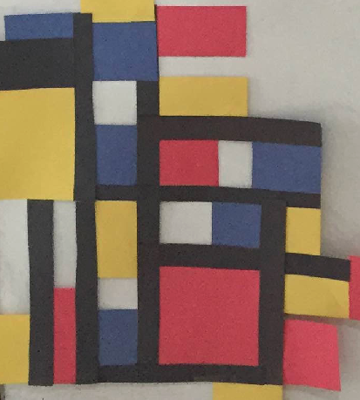

- INSTRUCTIONAL RESOURCES:

POWERPOINT SLIDES:
