I. OVERVIEW
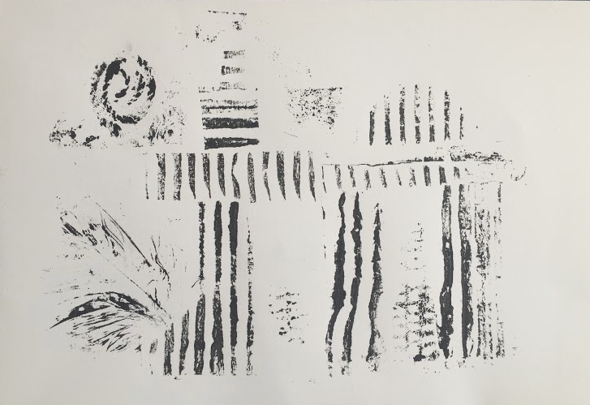

LESSON TITLE: Ancient Architexture: An Exploration in Collagraph Printmaking
LESSON SUMMARY: In this lesson, students will be examining architecture from Ancient Greece and Rome. After reviewing what they know and doing some research of their own, they will construct collagraph prints that draw inspiration from the architecture they explored.

TEACHER(S) NAME: Taylor Hughes
GRADE LEVEL: 5
CLASS NAME: 5th Grade Art CLASS SIZE: 15-21 Students
CLASS TIME/DATE: 60 Minutes 1 Days/week 3 Total Session(s)/Days

A. BIG IDEA:
Place

B. ENDURING UNDERSTANDINGS:
Place can be described as a space, area, or spot, set apart or used for a particular purpose. Place is important in everyday life as people are always present in a place, have been in places (associated with memories), and envision themselves in places in the future. Emotions are often associated with different places as they evoke all sorts of memories or hopes. Place is important in everyday life as we can identify with certain locations in many ways. For example, a bedroom may be someone’s safe haven, serenity, or quiet place where they feel the most themselves. Throughout history, artists have explored place as a means of dealing with the past, present, and future. For instance, an environmental artist may explore place by address environmental issues of a certain location or larger world.

C. ESSENTIAL QUESTIONS:
- What is place?
- What does place mean in artmaking?
- What is abstraction?
- How is architecture related to fine art? And vice versa?
- How can we draw inspiration from ancient architecture as artists in today’s society? Why is it important to do so?

D. BACKGROUND INFORMATION
Prior to this lesson, students at Ambrit International School are expected to have a basic understanding of some key elements of Ancient Greece and especially Roman architecture, seeing as it surrounds them in their daily lives. It is expected that many of them have never heard of or created a collagraph print at all, or even know what printmaking is. They should be able to do basic research on a computer (or tablet, using the internet), and come up with keywords to search in order to arrive at appropriate content. They are expected to be able to properly and maturely handle all materials in the art room.

E. MATERIALS/EQUIPMENT, ROOM ARRANGEMENT
1. MATERIALS/EQUIPMENT:
  - Mixed textured materials - cardboard, fabric, bubble wrap, etc. *some materials will vary because they are brought in by the students.
  - Scissors
  - Pre-cut cardboard plates, approx. 5”x9”
  - Paper, approx. 8”x11”
  - Liquid glue
  - Glue sticks
  - Tape
  - Tempera paint
  - Disposable tin tray
  - Sponge brayers
2. ROOM ARRANGEMENT:
  - The room will be arranged so that students sit in groups at tables, with a maximum of 6 students at a table. All students will have a clear view of the projector at the front of the room, as well as easy access to all necessary art materials. There are two stations of materials on either side of the room, each stocked with markers, colored pencils, scissors, and glue, so that traffic to retrieve their own materials is not an issue. There are also center units at each table; containing small but sufficient amounts of markers, colored pencils, drawing pencils, pencil sharpeners, and erasers.

F. VOCABULARY and REFERENCES/SOURCES
- VOCABULARY:
- Architecture: the art or practice of designing and constructing buildings.
- Texture: the feel, appearance, or consistency of a surface or a substance.
- Representin’: Proclaiming one’s identity and affiliations
- Place: a location or setting
- Collagraph Printmaking: an art process in which materials are adhered to a rigid substrate (i.e. cardboard), which is then inked and used to produce one or more prints.
- REFERENCES/SOURCES:
  - http://www.ancient.eu/Roman_Architecture/
  - http://www.historyforkids.net/ancient-greek-architecture.html

II. OBJECTIVES and STANDARDS

A. OBJECTIVES:
- The students will be able to exhibit an understanding of Greek and Roman architecture through a group warm-up as well as class discussion throughout the course of the project.
- The students will be able to expand on their knowledge of Greek and Roman architecture through independent research.
- The students will be able to transform their knowledge of Greek and Roman architecture into a visual representation through the artmaking activity.
- The students will be able to create a collagraph plate and resulting series of three prints through the artmaking activity.

B. STANDARDS
- NJCCC Art:
  - 1.1.5.D.1: Identify the elements of art and principles of design that are present in everyday life.
In this lesson, students will be examining work from their everyday life, in the form of Ancient Roman and Greek architecture that surrounds them.
  - 1.2.5.A.3: Determine the impact of significant contributions of individual artists in dance, music, theatre, and visual art from diverse cultures throughout history.
In this lesson, students will be discussing the impact of significant contributions from Greek and Roman history.
  - 1.3.5.D.1:Work individually and collaboratively to create two- and three-dimensional works of art that make cohesive visual statements and that employ the elements of art and principles of design.
Students will be working collaboratively with the day one warm-up, and individually throughout the rest of the activity to create a two-dimensional work of art that has a strong focus on texture and abstraction.
- NJCCC Non-art Subject:
  - 6.2.8.D.3.c: Evaluate the importance and enduring legacy of the major achievements of Greece, Rome, India, and China over time.
In this lesson, students will be examining architecture from Ancient Greece and Rome, and will be examining how this work is still relevant in their lives today.
- National Core Visual Arts Standards (NCCAS):
  - VA:Cr1.2.5: Identify and demonstrate diverse methods of artistic investigation to choose an approach for beginning a work of art.
    - In this lesson, students will be conducting technical historical research to begin their artmaking activity.

III. LEARNING EXPERIENCE

A. INTRODUCTION:
- DAY 1
- Hook/Topic Question or Introductory Activity (Pre-Assessment): Students will walk into class after lining up at the door and will see nothing but markers and one large piece of white paper on each table - unusual for the students, seeing as they always walk into class to see their center units of materials on their tables. They will be told to sit quietly in their seats. When all students are seated, the teacher will tell the students to draw/write/describe anything they know or think they know about Greek and Roman architecture. The teacher will then start a timer for 5 minutes. After the timer goes off, students will be told to put markers away and will briefly discuss some of the things they listed/illustrated on their papers. The instructor will then show the students a slide with images of noteworthy elements of architecture from this period.
- Introduction of big idea: “Why is it important to reflect on Ancient Greece and especially Ancient Roman architecture? Why is it important to do this in the art room?”

B. SEQUENCE OF ACTIVITIES/ORGANIZER
DAY 1 continued
- Instructor will then transition to discussing the artmaking activity by telling students that they will be using their knowledge of Ancient Greek and Roman architecture to create an abstract work of art.
  - “What is abstract art? How can we create an abstract work of art using knowledge of ancient architecture?”
- Instructor will then transition into discussion of collagraph printmaking, showing students pictures on the slideshow.
  - “If collagraph printmaking is a study of texture, how can we gain inspiration from architecture to create a successful collagraph print? What elements can we focus on?”
- Instructor will discuss the basic process of creating a collagraph print, telling students they will be using cardboard plates and an assortment of supplied textured materials. Instructor will then show students her plate, explaining how each part is inspired by Ancient Greek and Roman architecture.
  - “What element of architecture was I examining when I used ____? (plate material)”
- DEMONSTRATION: For a demonstration on the first day, the instructor will show students how to properly adhere various materials to the cardboard plate, using liquid glue. The instructor will also encourage students to manipulate and experiment with the materials - for example, she will show students how to split corrugated cardboard into different layers, using each to his/her advantage.
- Instructor will answer any questions that students have, and will ask for a volunteer to hand out a pre-cut piece of cardboard to each student. Before students proceed with anything else, they will be told to put their names on the back of their plates.
- Students will then be told that they must look to their iPads and do some minor research on Greek and Roman architecture in order to accurately represent some of the fundamentals of this time period in their work.
  - What key words can we plug into a search engine in order to come up with the best results? How can we gain inspiration from this imagery to create a collagraph plate?
- Instructor will then place bucket of textured materials in the center of the room, and will call students up by table to select a few different things they wish to begin to adhere to their plates. Students will have the remainder of the class to work, and teacher will circulate the room to address any immediate issues and answer any questions that students may have.
- Conclusion: When there are approximately 8 minutes left in class, students will begin cleaning up. All textured scraps will be saved in the bin, and students will volunteer to sweep the floor to return it to its prior clean state. Cardboard plates, if wet, will be stored on the drying rack. Dry plates will be collected by the instructor. Students will stand behind their seats when they are ready to line up, and will be dismissed by table to line up at the door and wait for their homeroom teacher.

DAY 2 (repeat for day 3 or 4, as necessary)
- Introduction: Students will line up at the door, and will enter the room when they are quiet and ready to begin the class. They will have the opportunity to sit in the seats that they want to, as long as they sit boy/girl/boy/girl.
  - Instructor will ask students to discuss what they were doing the previous week.
  - “What kind of art are we making? What are we gaining inspiration from? Why is it important to do this in the art room? What are some of the most important elements of collagraph printmaking? How can we ensure that we are successful?”
- Artmaking Activity- Students will continue working on and finishing their collagraph plates. Instructor will explain that all students should finish their plates by the end of the class period, so that they are finished and ready to be printed the following week. Instructor will circulate the room as students work, addressing concerns and answering questions. Instructor will leave projector slide on the screen containing an example of a collagraph plate and resulting print.
- Conclusion: When there are approximately 8 minutes left in class, students will begin cleaning up. All textured scraps will be saved in the bin, and students will volunteer to sweep the floor to return it to its prior clean state. Cardboard plates, if wet, will be stored on the drying rack. Dry plates will be collected by the instructor. Students will stand behind their seats when they are ready to line up, and will be dismissed by table to line up at the door and wait for their homeroom teacher. When students are in line, instructor will inform them that they will be printing their plates in the next class.

DAY 3 (if needed, repeat info from above)
- Introduction: Students will line up at the door, and will enter the room when they are quiet and ready to begin the class. They will have the opportunity to sit in the seats that they want to, as long as they sit boy/girl/boy/girl.
  - Instructor will ask students to discuss what they were doing the previous week.
  - “What kind of art are we making? What are we gaining inspiration from? Why is it important to do this in the art room? What are some of the most important elements of collagraph printmaking? How can we ensure that we are successful?”
- Instructor will then go over some fundamentals of printmaking on the dry erase board. The instructor will explain proper registration and editioning by drawing a diagram on the board. The instructor will tell students that they will be printing in groups, but that everyone must properly edition their papers prior to printing. Each student will create three prints.
- Instructor will set up a table in the back of the room as a printing station. Students will be called up four at a time to print their plates. Those students not printing will continue with designing their iPad covers.
- DEMONSTRATION: Students at the printing station will be given a demonstration on how to properly pull a print. The teacher will have her example of a plate ready to print. Instructor will explain the tools - brayer, plate, ink - and the process of pulling a relief print. The instructor will show students how to properly roll ink onto the plate, and burnish the back of the paper to ensure that the image is transferred. Students will observe as teacher pulls her own print, and then proceed to create their own as teacher monitors process. When students are finished, they will place prints in the drying rack and pick another student to begin printing.
- The last group of students will be responsible for cleaning up the printing station. Three students will wash brayers, and another will clean out the tray for inking. The rest of the students will be responsible for cleaning up all other materials that they were using.

C. CLOSURE/CULMINATING EXPERIENCE
DAY 3
- When students are entirely cleaned up, they will each retrieve one of their prints from the drying rack that they think came out the best.
- Teacher will ask students to volunteer to talk about their artwork.
  - “Why is this your best print? What issues did you have? What do you think are the strongest parts about this piece?”
- Instructor will ask questions to the class to answer about their classmate’s work:
  - What elements of Greek and Roman Architecture do you think inspired your classmate? How can you tell? Do you think this is a good representation of the time period?
- Instructor will repeat with several students as they volunteer.
- Students will then hang up their work on the large bulletin board in the classroom.
D. ADAPTATIONS/MODIFICATIONS
- Adaptations and Modifications:
- Students with Developmental Delays: Students with developmental delays will need more thorough instruction and one-on-one time. Because a large portion of this artmaking activity allows for independent work time, the instructor will be able to repeatedly monitor the progress of the student with a developmental delay. This student will receive extra instruction after the preliminary directions are administered to the class, and will be closely monitored during the printing process. This student may need extra assistance in the research process.
- Student with Visual Impairment: Because this artmaking activity heavily focuses on texture, the student with visual impairment will be able to create a successful composition. This student will be given a pile of textured materials instead of having to retrieve them, and will be guided to know where their plate is. All materials will be explained and the instructor will guide the student’s hand to their location, placed on their desk in front of them. The instructor will allow the student to spend time examining the texture of the materials, and will regularly check on the student to make sure they are gluing all materials properly onto the plate.

- Differentiated Instruction:
- Students will experience both independent work time as well as scaffolding. The students will be able to work independently when experimenting with textures and assembling their plates. They will be scaffolded during the printing process, in which the instructor will be working closely with each student to ensure that the process goes smoothly.
- How will you differentiate your instruction/teaching for the general population of students with varying abilities? Make a list of 5-10 strategies that you will use in the lesson to ensure all students learn/create? Will you use demonstrations (for visual learners), flexible grouping, hands-on projects (for bodily-kinesthetic learners), on-going formative assessments, open-ended activities, scaffolding, student interest, student self-assessment, tiered activities (steps), varied questioning, group work, varied texts and materials, varied pacing, varied amount of teacher support, etc.
  - Think ahead! What can you do to ensure all students have an equal and productive learning experience in art? Consider special supplies and materials, student helpers, physical arrangements and strategies that allow special needs children the chance to participate and learn from each other. Differentiate your instruction/teaching to meet the varying needs of the students. How did you address different learning styles (visual, auditory, Tactile/Kinesthetic, etc.)?
  - You may also state how your teaching/lesson address Gardner’s multiple intelligences and teaches toward various learning styles: Visual-Spatial, Bodily-kinesthetic, Musical, Interpersonal, Intrapersonal, Linguistic, and Logical–Mathematical.

IV. LESSON ANALYSIS

A. STUDENT ASSESSMENT

1. Pre-Assessment: Class-wide discussion on architecture and abstraction

2. Formative Assessment: Warm-up group activity writing down what students know about Greek and Roman architecture, artmaking activity

3. Summative Assessment: Rubric
Criteria/Objective | Exemplary (A) | Good (B) | Satisfactory (C) | Needs Improvement
The students will be able to exhibit an understanding of Greek and Roman architecture through a group warm-up as well as class discussion throughout the course of the project. | Student exceeded expectations during group work. Student worked extremely well with classmates, added insightful ideas to the brainstorming activity, and was willing and able to discuss his/her ideas. | Student met expectations during group work. Student worked well with classmates, added insightful ideas to the brainstorming activity, and was willing and able to discuss his/her ideas. | Student sometimes met expectations during group work. Student worked somewhat with classmates, added a few ideas to the brainstorming activity, and was sometimes willing to discuss his/her ideas. | Student rarely met expectations during group work. Student struggled to cooperate with classmates, added a few if any ideas to the brainstorming activity, and was rarely willing to discuss his/her ideas.
 | The student frequently participated during all class discussions. S/he raised hand to contribute insightful knowledge. | The student participated during all class discussions. S/he raised hand to contribute insightful knowledge. | The student participated during most class discussions. S/he raised hand to contribute i knowledge. | The student rarely participated during all class discussions. S/he did not raise hand to contribute insightful knowledge.
The students will be able to expand on their knowledge of Greek and Roman architecture through independent research. | The student successfully used available methods of research to expand his/her knowledge on the topic. Their use of technology was appropriate and extremely useful for their assignment. | The student used available methods of research to expand his/her knowledge on the topic. Their use of technology was appropriate and useful for their assignment. | The student sometimes used available methods of research to expand his/her knowledge on the topic. Their use of technology was sometimes appropriate and useful for their assignment. | The student rarely used available methods of research to expand his/her knowledge on the topic. Their use of technology was inappropriate and not useful for their assignment.
The students will be able to transform their knowledge of Greek and Roman architecture into a visual representation through the artmaking activity. | The student showed a clear understanding of how to represent architecture in an abstract way. The influence is very clear but the final print remains non-representational. | The student showed an understanding of how to represent architecture in an abstract way. The influence is clear but the final print remains non-representational. | The student showed somewhat of an understanding of how to represent architecture in an abstract way. The influence is somewhat clear although the final print is somewhat representational rather than abstract. | The student failed to show an understanding of how to represent architecture in an abstract way. The influence may be clear but the student failed to turn visual imagery from Greek and Roman architecture into an abstract representation.
The students will be able to create a collagraph plate and resulting series of three prints through the artmaking activity. | The student showed extreme care in the creation of their plate and final print. They used materials appropriately and efficiently, and were careful register their plate the correct way. Student was helpful in cleaning up the materials and worked in a timely manner. | The student showed care in the creation of their plate and final print. They used materials appropriately and efficiently, and were careful register their plate the correct way. Student was helpful in cleaning up the materials and worked in a timely manner. | The student showed some care in the creation of their plate and final print. They used materials somewhat appropriately, and were able to register their plate the correct way. Student was helpful in cleaning up the materials but did not work in the most timely manner. | The student showed little to no care in the creation of their plate and final print. They used materials inappropriately, and were unable to register their plate the correct way. Student was not helpful in cleaning up the materials and failed to use time wisely.
Total Points or Grade:

Teacher Comments:

B. ASSESSING ARTWORK

- Exemplary (strongest) example:
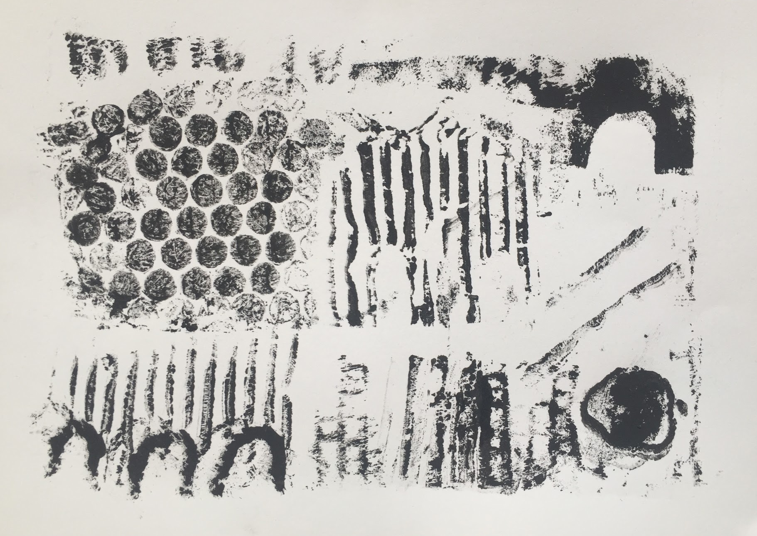
This student successfully drew inspiration from Greek and Roman architecture in an abstract way. There is obvious reference to cobble stones, arches, and columns, however it is not representational of one specific element of architecture. It is printed very neatly and evenly.
- Great/Good (average) example:
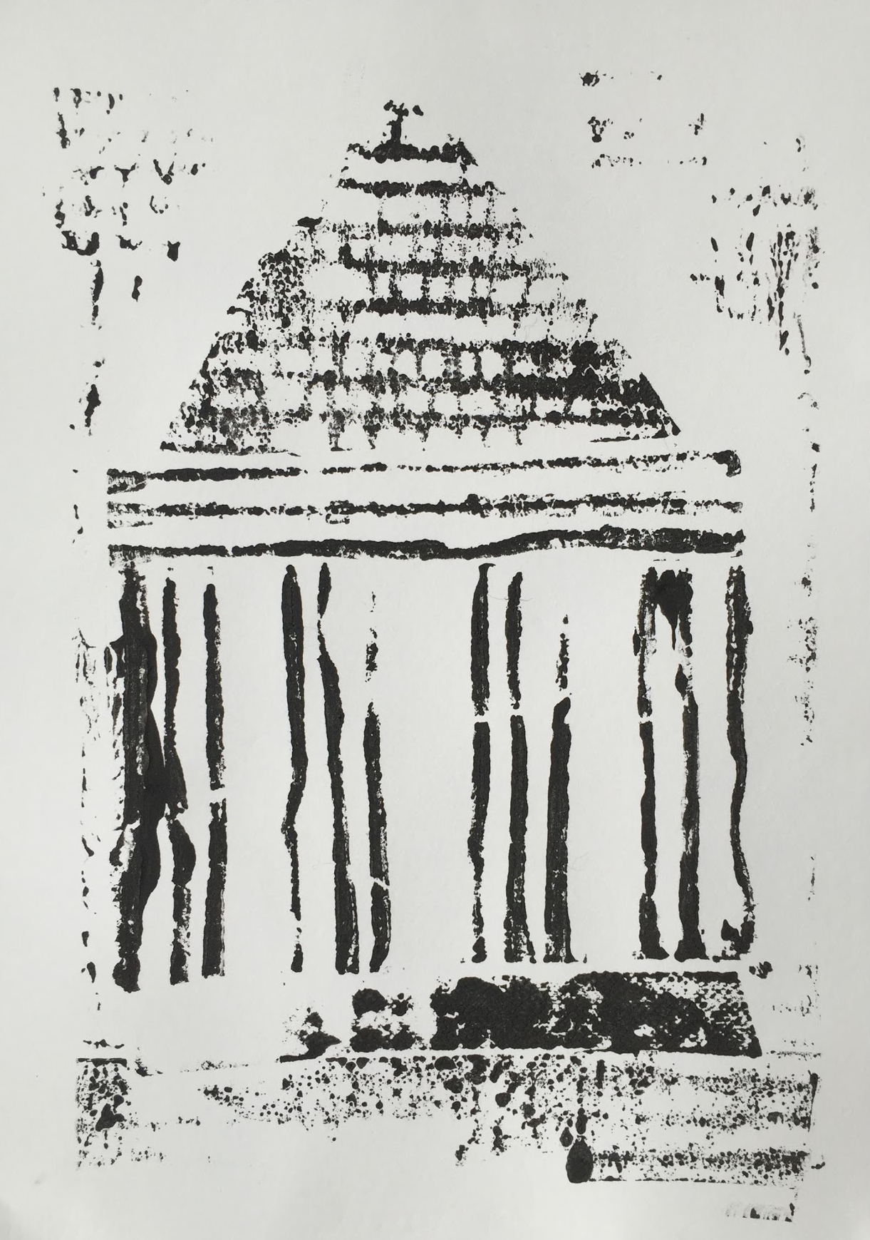
This student, although was able to print well and neatly, did not try to represent elements from architecture in an abstract way. The student clearly tried to represent one specific element - most likely a temple - instead of taking parts of several different structures.
- Satisfactory or Unsatisfactory (weakest) example:
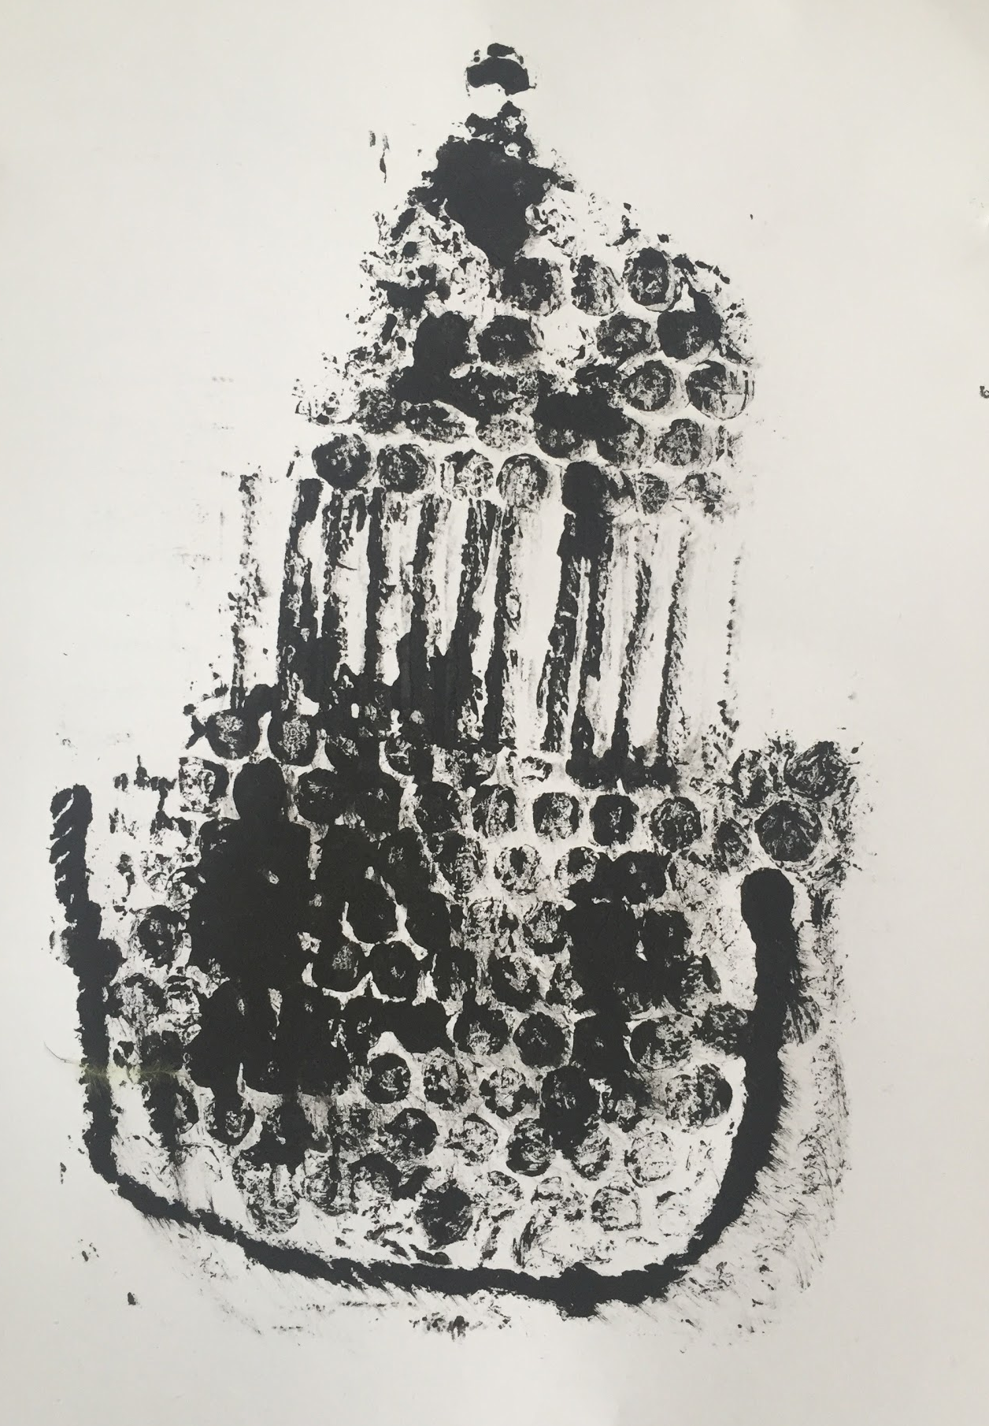 This student failed to represent the architecture in an abstract way. The printing was done hastily and is not neat. The student rushed and did not take the care to produce a successful piece.

C. SELF-REFLECTION (Your thoughts on how the lesson went)
One of the most successful parts of this lesson was having the opportunity to teach a group of students about architecture that exists in their own world. The students were able to reference the city in which they live to create works of art, making it that much more meaningful. The students were also very excited to engage in an art form they had little to no experience with. They were extremely excited to print on the final day of the lesson, and seemed pleased with the final results.
One aspect of the lesson I wish worked out differently was the textured materials the students utilized. Because the students only had art once a week, they forgot to bring in their own supplies to class to use, after not having had art for an entire week. As a result a lot of the prints appear similar because they all used the same main materials (cardboard, bubble wrap, and string).

V. SUPPLEMENTAL MATERIAL

- TEACHER EXEMPLAR:
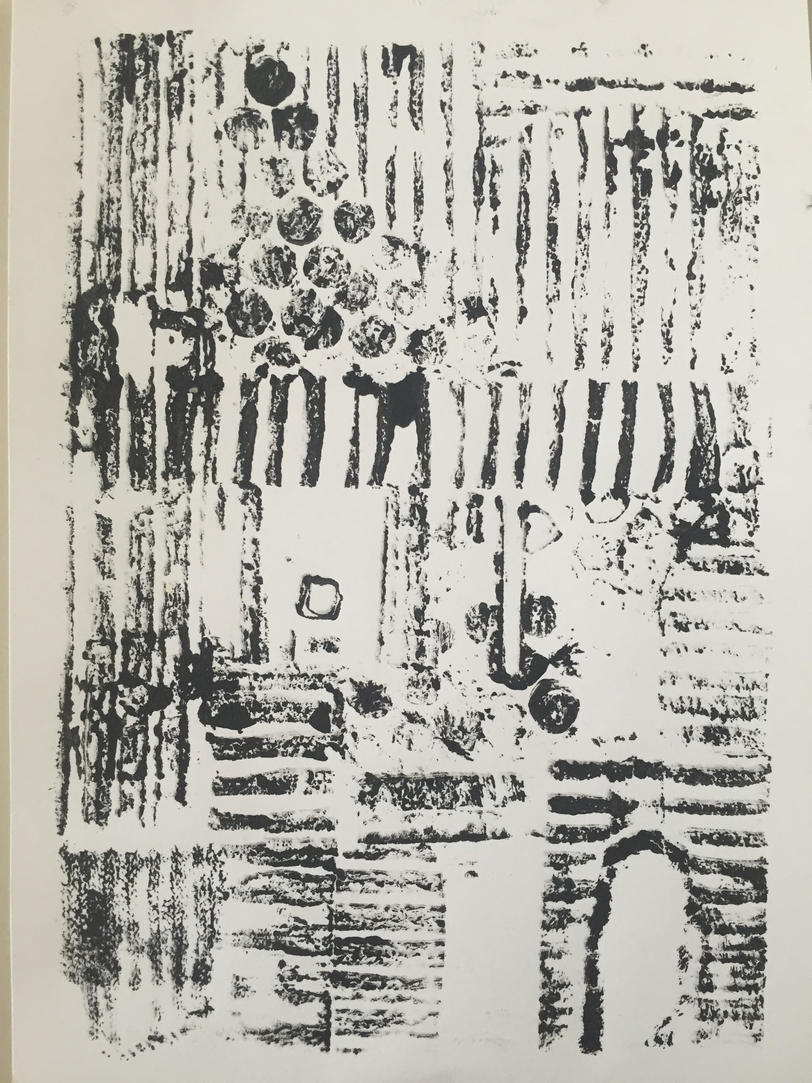
- INSTRUCTIONAL RESOURCES:
- PowerPoint Slides
