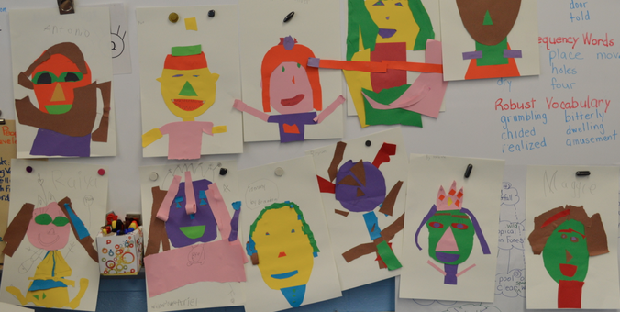
LESSON TITLE: Shape Up: Creating Cut Paper Portraits
LESSON SUMMARY: Students will be engaging in an artmaking activity in which they use collage techniques to create a portrait of one of their classmates. By studying the “Wasteland” projects of Vik Muniz, students will be inspired by his work, and will use cut pieces of construction paper to emulate his techniques, all the while gaining an appreciation for art’s ability to celebrate figures from one’s place of origin.
GRADE LEVEL: Kindergarten, 1st, and 2nd grade

BIG IDEA: Community Roles
ENDURING UNDERSTANDINGS: Community roles refer to the interconnectedness and interdependence among the members of a community. Each individual plays a different, important role in making a community function, whether that role is defined in terms of the person’s occupation or relationship to others. Students should know that the big idea refers to the cooperation among people living in a certain location, and it is this cooperation that makes a community function. They will benefit from a comprehension of community roles because it will guide their decision-making and behavior towards roles that are constructive in society.

ESSENTIAL QUESTIONS:
- What is a role in our community? Does everyone have a role?
- Are all communities be the same? How can they be different?
- How can our community inspire us to make art?
- How can art celebrate members of our hometown community?

MATERIALS/EQUIPTMENT:
- 11”x18” drawing paper
- Scissors
- Glue sticks
- Construction paper of various colors

STANDARDS:
ART STANDARDS:
1.1.2.D.2: Identify elements of art and principles of design in specific works of art and explain how they are used.
This standard applies to the lesson because students will be examining the work of Vik Muniz, paying special attention to the different shapes of the materials and how they contribute to the overall work.

1.2.2.A.2: Identify how artists and specific works of dance, music, theatre, and visual art reflect, and are affected by, past and present cultures.
This standard applies to the lesson because students will be examining works of art from a culture across the world, and connecting it to the community in which it was produced.

1.3.2.D.1: Create two- and three-dimensional works of art using the basic elements of color, line, shape, form, texture, and space, as well as a variety of art mediums and application methods.
The students will be creating a work of two-dimensional art that specifically explores color and shape, using the new technique of collage.

NON-ART STANDARDS
21st Century Life and Careers:
9.3.4.A.2: Identify various life roles and civic and work-related activities in the school, home, and community.
Students will be examining a community across the world, exploring the life of landfill-pickers in Rio de Janeiro, Brazil. Students will be exposed to unfamiliar roles and occupations, and will use this new knowledge to reflect on the roles within their own community.

OBJECTIVES:
- The students will be able to exhibit an understanding of hometown community by contributing to discussion and offering their own definitions, both before and after the artmaking activity.
- The students will be able to examine the work of Vik Muniz and verbally explain how it relates to community.
- The students will be able to create a collage portrait of a classmate by layering construction paper.
- The students will demonstrate an understanding of shape by ripping and cutting different shapes of construction paper to assemble a portrait.

