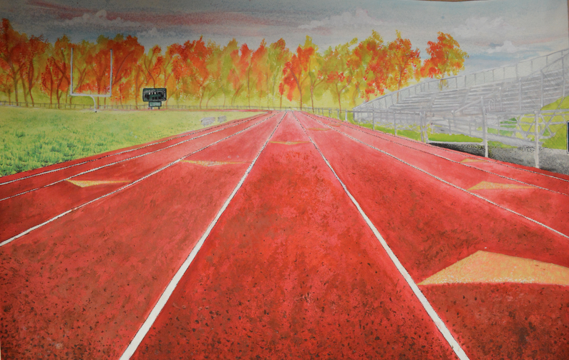
LESSON TITLE: One-Place Perspective
LESSON SUMMARY: In this lesson, students will be creating drawings using watercolor and thin sharpie pen to express a place at which they feel the most themselves. Inspired from a New Orleans based artist, Terrance Osborne, students will use one-point perspective and color to demonstrate the aura of a place.

GRADE LEVEL: 9th – 12th (Art Fundamentals)

BIG IDEA: Place
ENDURING UNDERSTANDINGS: Place can be described as a space, area, or spot, set apart or used for a particular purpose. Place is important in everyday life as people are always present in a place, have been in places (associated with memories), and envision themselves in places in the future. Emotions are often associated with different places as they evoke all sorts of memories or hopes. Place is important in everyday life as we can identify with certain locations in many ways. For example, a bedroom may be someone’s safe haven, serenity, or quiet place where they feel the most themselves. Throughout history, artists have explored place as a means of dealing with the past, present, and future. For instance, an environmental artist may explore place by address environmental issues of a certain location or larger world.

ESSENTIAL QUESTIONS
- What is place?
- Why is place important?
- How is place examined in artmaking?
- Why is it important to understand the importance of place in everyday life?

MATERIALS/EQUIPMENT
- Watercolors in all colors (Tubes and trays)
- Watercolor paper
- Pencil
- Sketchbooks
- Extra fine sharpie pens (2 each)
- Rulers
- PowerPoint and Projector
- Doc Cam
- Paint Brushes
- Colored Pencil/ Watercolor Pencil
STANDARDS
NJCCC ART STANDARDS:
1.2.12.D.2: Produce an original body of artwork in one or more art mediums that demonstrates mastery of visual literacy, methods, techniques, and cultural understanding.
The students will be creating an original body of artwork in watercolor paint and Sharpie to demonstrate their mastery of visual literacy and techniques in the medium.

1.2.12.D.5: Identify the styles and artistic processes used in the creation of culturally and historically diverse two- and three-dimensional artworks, and emulate those styles by creating an original body of work.
The students will be studying the work of Terrance Osborne, an artist they have most likely never seen before, and will be emulating aspect of his style in an original body of work.

1.4.12.B.2: Evaluate how an artist’s technical proficiency may affect the creation or presentation of a work of art, as well as how the context in which a work is performed or shown may impact perceptions of its significance/meaning.
The students will be critiquing both the work of Terrance Osborne and their peers to determine technical proficiency, and how it affects the creation or presentation of their work. They will also be discussing the perceptions and the significance/meaning.

NJCCC NON-ART SUBJECT: 21st Century Life and Careers:
9.1.4.8.2: Evaluate available resources that will assist in problem solving.
In this lesson, the students will be given the challenge of using watercolor paint in new and innovative ways. They must be able to evaluate the resources (paint) and determine the different ways in which it will aid in their overall artistic success.

NATIONAL CORE VISUAL ARTS STANDARDS
#MA:Re7.1
- Anchor Standard: Perceive and analyze artistic work.
- Enduring Understanding: Identifying the qualities and characteristics of media artworks improves one's artistic appreciation and production.
- Essential Question: How do we ‘read’ media artworks and discern their relational components? How do media artworks function to convey meaning and manage audience experience?
  - This comes into play during the critique and analysis sections of the lesson, when students examine the work of Terrance Osborne as well as that of their peers.

OBJECTIVES
- The students will be able to create the illusion of three-dimensions on a two-dimensional surface through the technique of one-point perspective.
- The students will be able to critically analyze the work of Terrance Osborne through class discussion and critique.
- The students will explore place through the creation of an architecturally-based drawing.
- The students will be able to display an understanding of the connection between color theory and emotional experiences through the artmaking activity.

