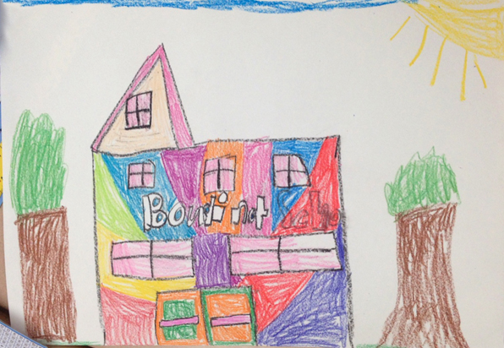

LESSON TITLE: Plan Your Utopia: An Exploration in Public Art
LESSON SUMMARY: Through examination of the work of Isaiah Zagar in Philadelphia, students will be gaining an outlook into the idea of enhancing local community with public art. The students will draw a building that is locally or personally significant, and formulate ideas of how they would enhance it with public art. Students will study the basic structure behind a public art proposal and use these skills to present their ideas to their peers.
GRADE LEVEL: Kindergarten, 1st, and 2nd grade classes

BIG IDEA: Enhancing Local Community
ENDURING UNDERSTANDINGS: Enhancing local community in this lesson refers to the idea of improving a public place with large or small-scale public art. For decades, artists have been examining areas throughout the world that need physical improvement, and are using art to do so - murals, mosaics, gardens, etc. By providing students with information about an art form they may not be aware of, we hope that they will move forward with insight and positive ideas for their own artwork throughout the community.

ESSENTIAL QUESTIONS:
- What is public art?
- What is a mosaic?
- How can art be used to make an area in the town better?
- Is public art always a good thing? How can we make sure that the work we do will better the community?

MATERIALS/EQUIPTMENT:
- 11”x18” drawing paper
- Construction paper of various colors
- Scissors
- Glue sticks
- Crayons
- Pencils and erasers
- SmartBoard (or projector), computer, and PowerPoint presentation

STANDARDS
ART STANDARDS:
1.3.2.D.5: Create works of art that are based on observations of the physical world and that illustrate how art is part of everyday life, using a variety of art mediums and art media.
This standard applies to the lesson because students will be observing public art throughout their local community and discuss how it becomes a part of their everyday life. They will be designing a community art project that may utilize various art mediums.

1.4.5.A.3: Demonstrate how art communicates ideas about personal and social values and is inspired by an individual’s imagination and frame of reference (e.g., personal, social, political, historical context).
This standard applies to the lesson because students will be demonstrating their own personal ideas by creating a work of art on a significant structure in their lives (house, school, building in the town, etc.).

1.1.2.D.2: Identify elements of art and principles of design in specific works of art and explain how they are used.
This standard applies to the lesson because students will be examining the work of Isaiah Zagar, and during group discussion will be identifying different elements and principles throughout his mosaics.

NON-ART STANDARDS:
CCSS.ELA-LITERACY.SL.2.1.B: Build on others' talk in conversations by linking their comments to the remarks of others.
This standard applies to the lesson because students will engage in conversation about their artwork. At the end of class, they will pitch their ideas about their design, both to the teachers and their peers.

OBJECTIVES
- Students will be able to exhibit skills in making construction paper mosaics and drawings to create a proposal for a public artwork.
- Students will be able to draw upon their prior understanding of community to design a work of art that will enhance the community in which they live.
- Students will be able to examine the work of Isaiah Zagar and articulate how his work applies to theme of enhancing local community.
- Students will be able to exhibit an understanding of hybridity and multimedia artwork by creating a design that utilizes many different materials.
- Students will be able to articulate to the class how their design will contribute to their community, gaining and understanding of proposals for public artworks.

